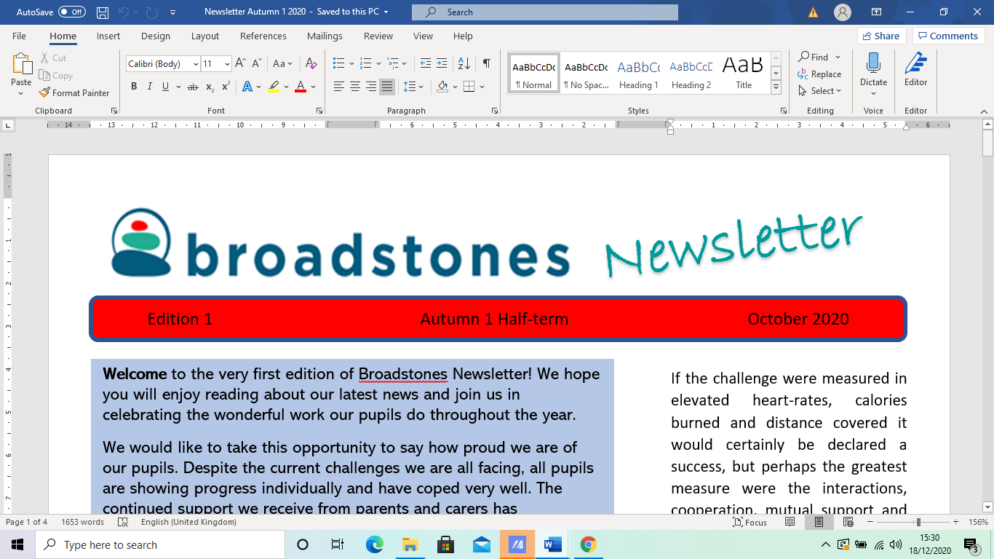
l

Edition 25 Autumn 2 December 2024

A warm and festive welcome to our 2024 Christmas edition newsletter.

We start by wishing you all a very merry Christmas and a very happy new year.

With a third of the school year drawing to a close, we reflect on the hard work of our pupils so far.

Every pupil has gained some level of certification this year with many excelling across several subject areas.

Our Y11’s have commenced preparations for work experience, and have seriously started to contemplate their post-16 options with some already applying to colleges.

In this edition you can read about: our Christmas celebrations activities; our plans to become even more ecologically efficient; our inset day; breast cancer fundraising; some recent school trips; as well as the usual curriculum area catch-up information.




El and Viv at the
Reddish Christmas Lights Switch-on

El and Viv made the school proud when they attended the Reddish Christmas Lights switch-on event held on 29th November in Houldsworth Square.

Leading up to the event, the art department was transformed into Santa's Grotto, as staff and pupils worked tirelessly creating a range of Christmas crafts, perfect for gifts and house decorations to sell at the event.

All their hard work paid off, resulting in extra funds to support the ever evolving art department.

Christmas Pantomime



A whole school trip to Stockport Plaza took place on 18th December to watch the pantomime Sleeping Beauty.

Most pupils (and staff) attended and had a lovely time, sharing in the slapstick, and soaking up the unique fusion of eccentricity, ambiguity and absurdity!

This is the second year running we have taken our young people to the pantomime, and we look forward to continuing this new tradition in years to come.
Oh yes we will!

Climate Action Now!

On Friday November 22nd, Dave Driver and Sue Gibbins demonstrated their determination to ensure that Broadstones School is ecologically invested.

They both attended the Climate Action Now 2024 Summit at Stockport Town Hall run by Stockport Council.

They took part in workshops, looking at the impact of climate change on our everyday lives.

They made some great contacts that the school will be able to work with both from a business and an educational angle.

Broadstones has signed up to the ‘Let’s go Zero’ by 2030 campaign and an advisor visited school to help set this up on December 4th.

Staff and pupils had already started thinking about ways for us all to be more mindful about preserving the environment, so armed with even more brilliant ideas, the school’s endeavours will be much more effective.

Sue Gibbins said: “We are hoping there will be some exciting projects in the future for our school to take part in, so watch this space!”

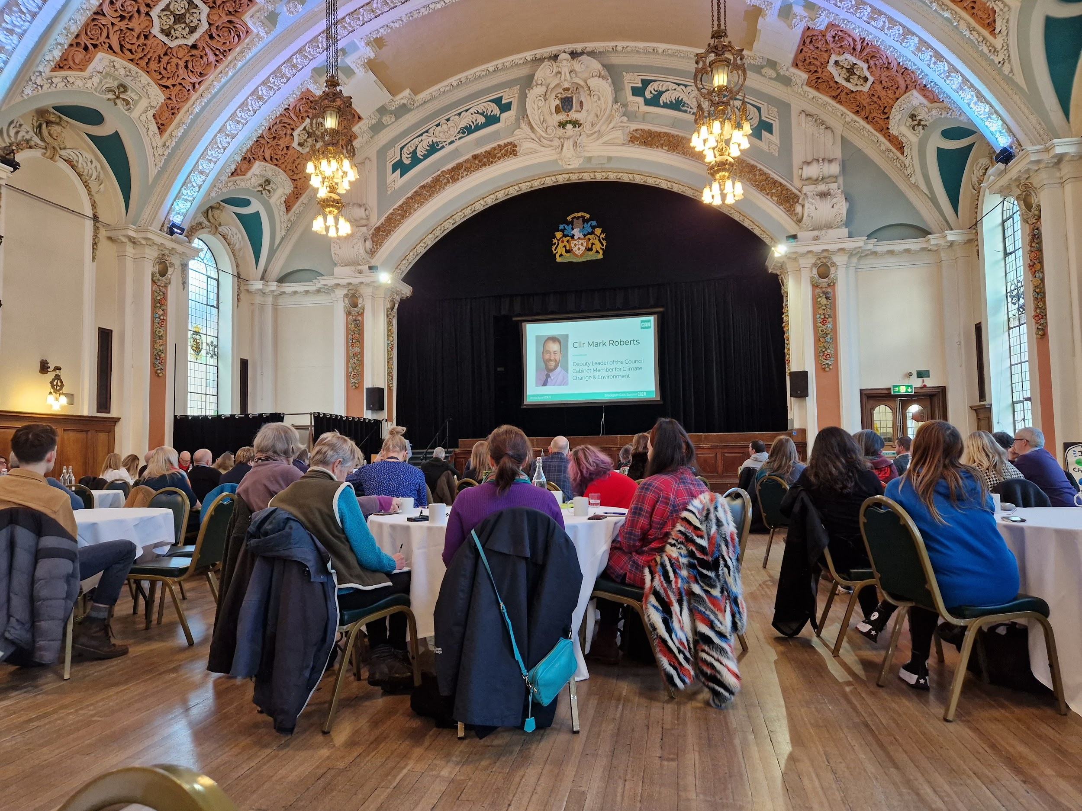
The Climate Action Now 2024 Summit at Stockport Town Hall

Staff Wellbeing Day

Sue and John organised a lovely inset morning for staff at the Everyman Theatre in Manchester.

For those not familiar with the theatre, it’s a premium end cinema experience, luxurious in decor, furnishing and dining.

Staff were treated to a lovely nutritious breakfast before settling down to watch the classic film The School of Rock, then it was off on an exciting shopping expedition, and in some cases, a liquid lunch, with the gift vouchers given.

Thanks for a lovely morning Sue and John - staff plan to meet up over the Christmas period with their Everyman vouchers that were also given to each staff member.

Science with Claire

In Science, some pupils have been extracting DNA from kiwi fruit, teaching them that DNA can also be found in plants as well as animals.

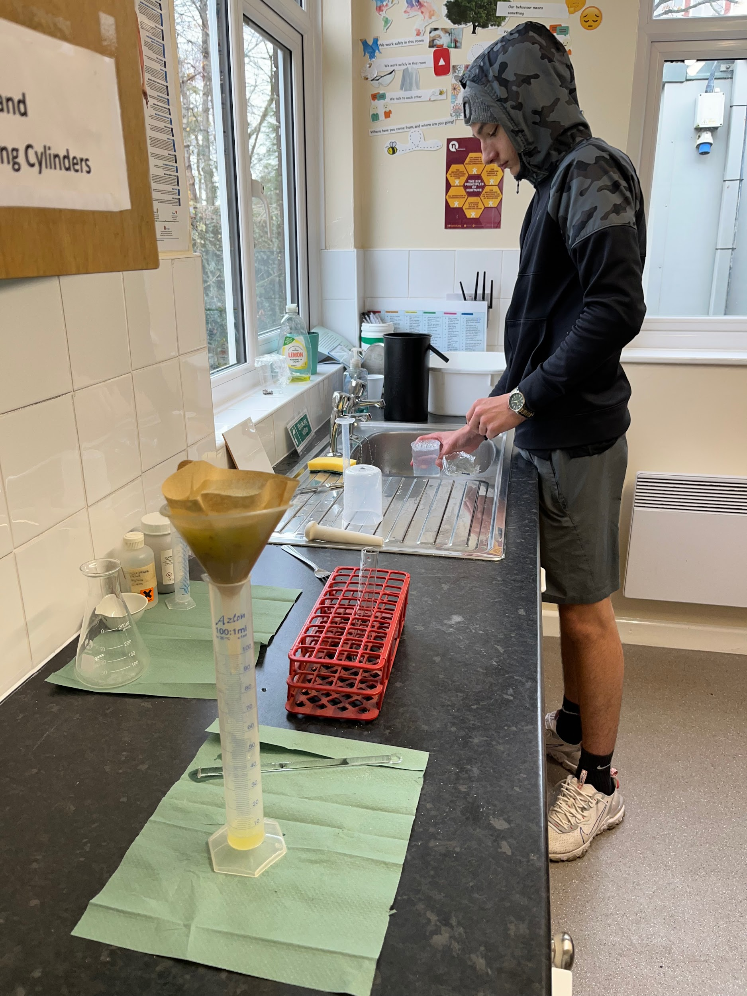
Richard extracting DNA from a kiwi

Others have been measuring mass using the mass balance, and also the volume of irregular shapes using the displacement can and measuring cylinder to calculate density.

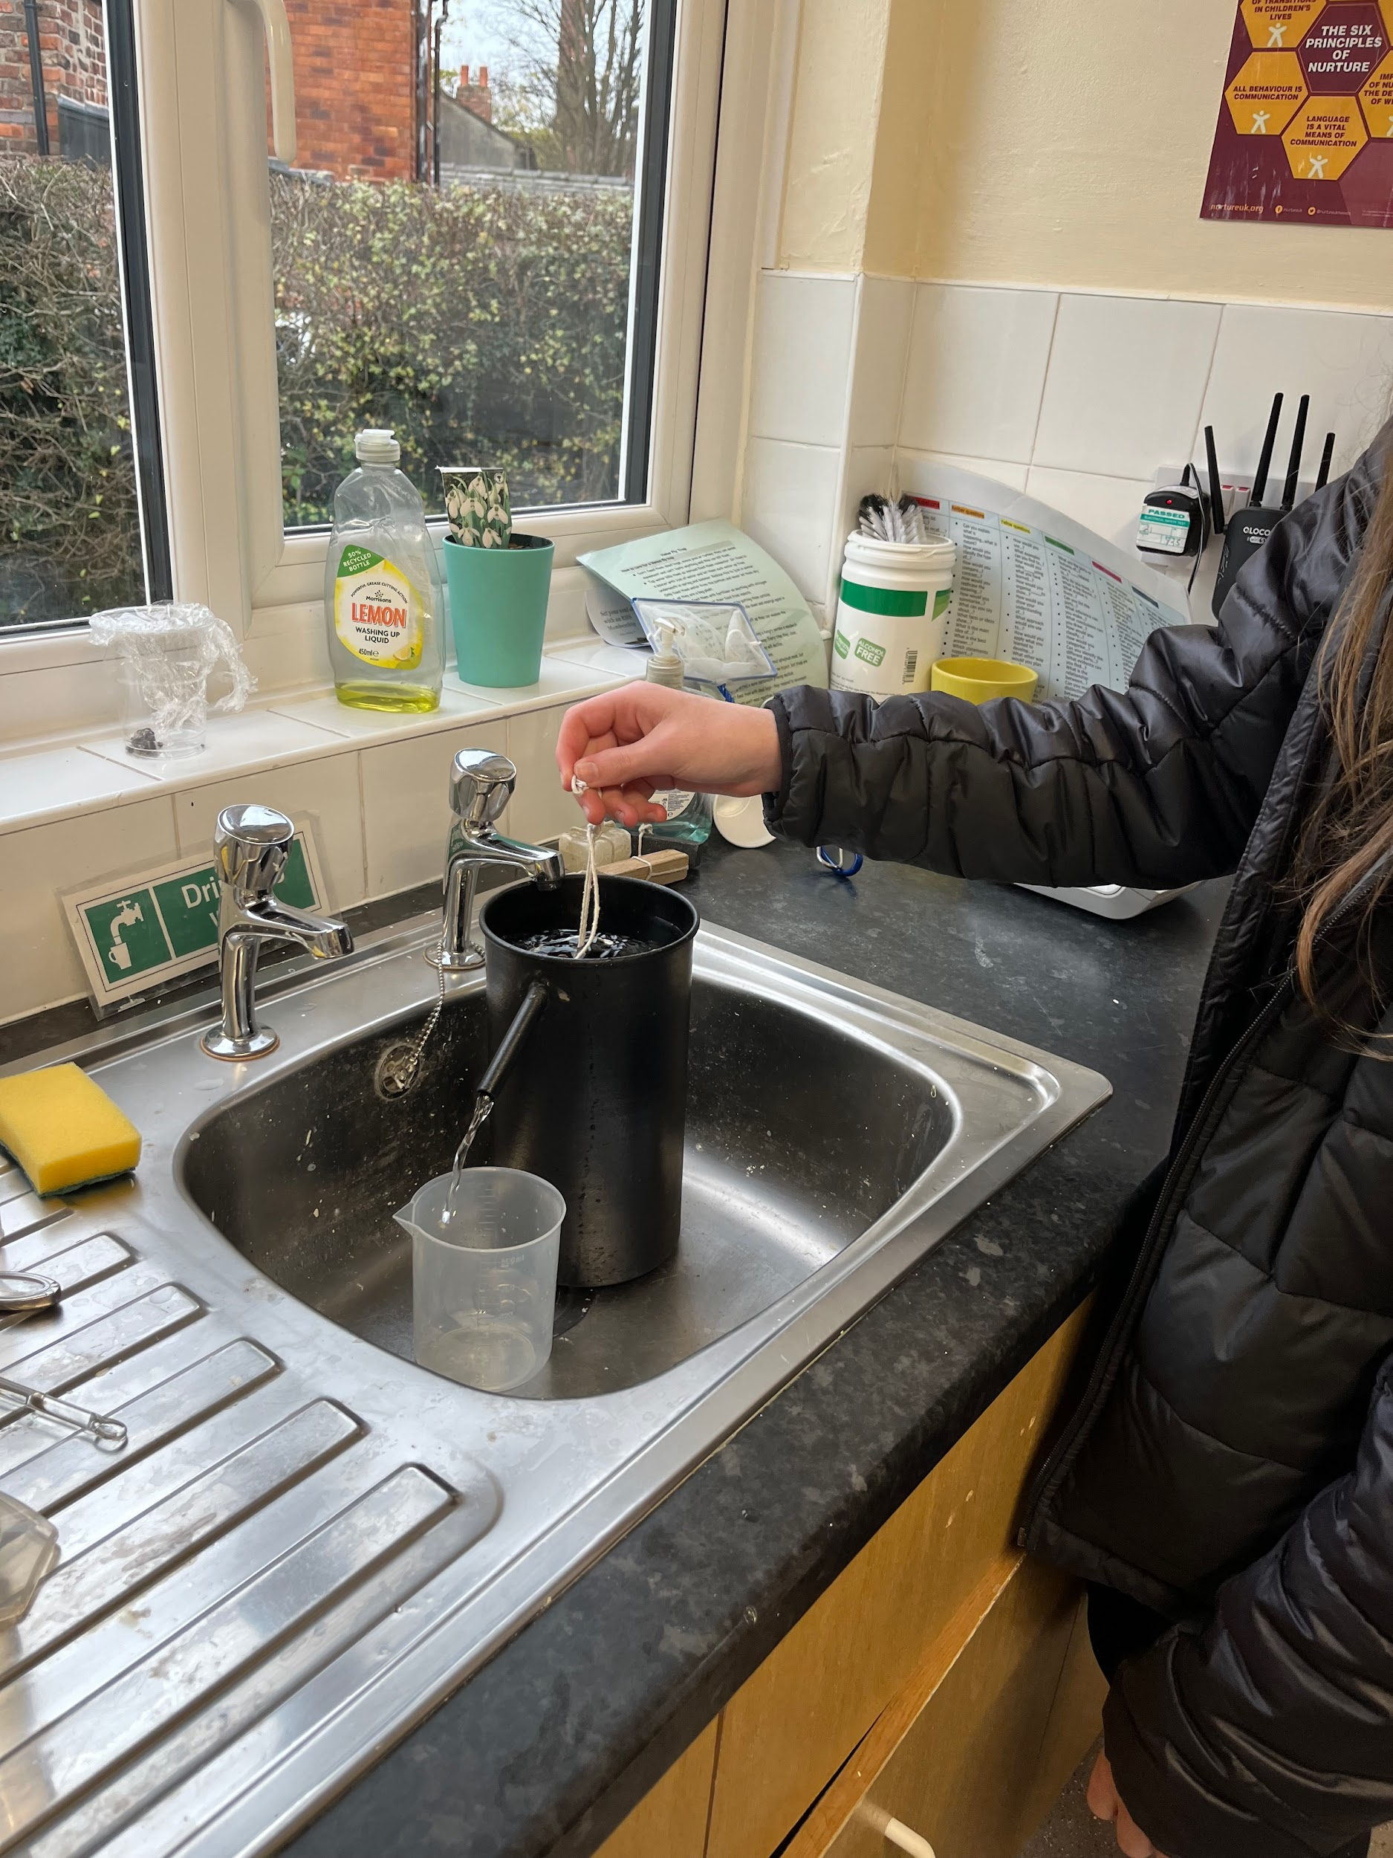
Sean measuring mass

English with Davina

Pupils in English have been learning about Charles Dickens’ A Christmas Carol and why it is well established amongst the English literary canon.

Also, last term’s £10 Amazon
voucher was awarded to Charlie, for his amazing work in editing the last newsletter - and for future ones too!

PSHE

PSHE groups all organised their own Christmas lunches again this year.

Manik’s group visited The Berretto Lounge in Stockport, where they enjoyed their version of festive fayre, with Alex’s group treated to a special just-for-them- opening at the Reddish Ale restaurant and Bar, where pupils were given a presentation from Craig, the owner, on the origins of all the organic seasonal and sustainably sourced ingredients used in their meals.

The previous week, Alex’s group also visited Staircase House in Stockport.

This popular attraction is fantastic for its representations and depictions of life spanning several eras.

Alex said: “We had a lovely time. The pupils got to literally see a house through time. And also loved the ice-cream that was thrown in for good measure!”

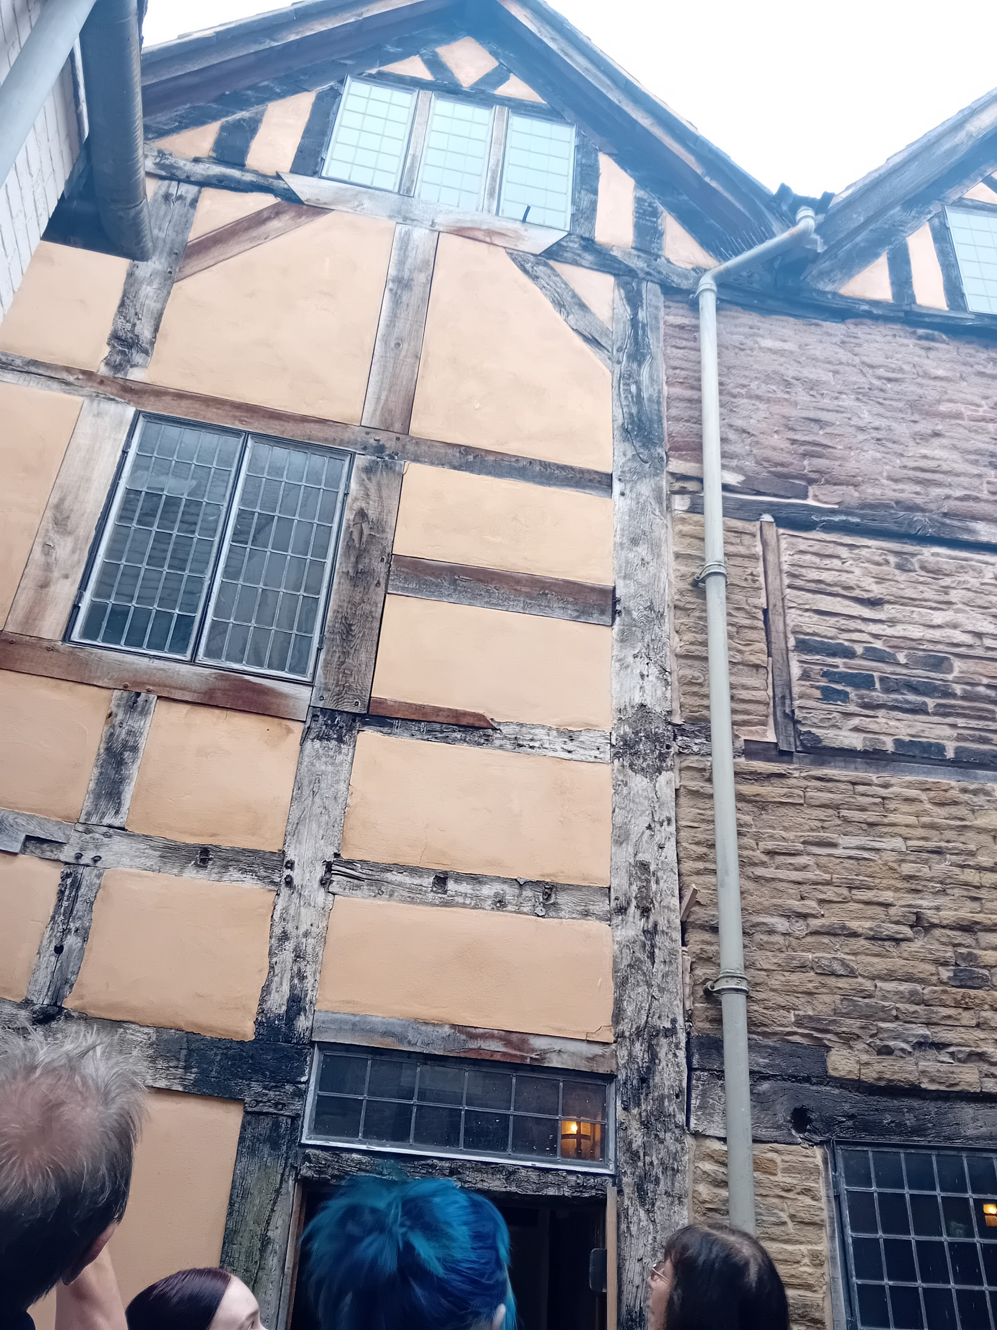
Looking at the traditional craftsmanship used at Staircase House

Festive Football

Amy, our dynamic PE tutor organised a staff versus pupils end of term football match. The stakes were high as both teams were out to win.

The match was tense with more than one hand ball by the sounds of it. Dave, Deputy Head was accused of cheating - effectively standing guard in the teachers’ net, although to be fair, and given the opportunity, he would probably deny this.

The player of the match was arguably Kayden with his sensational winning last goal. Followed by Richard who was also impressive on the day scoring a fair few. Richard said: “I could have got another goal but Ed said I was off-side - I clearly wasn’t.”

Amy commented: “We [the staff] need to be more efficient with the ball, get fitter, and ultimately, learn some of the rules of the game.”

However, as close as it was, pupils maintained the lead and the match ended with a 5 - 4 win for them.

Well done pupils!

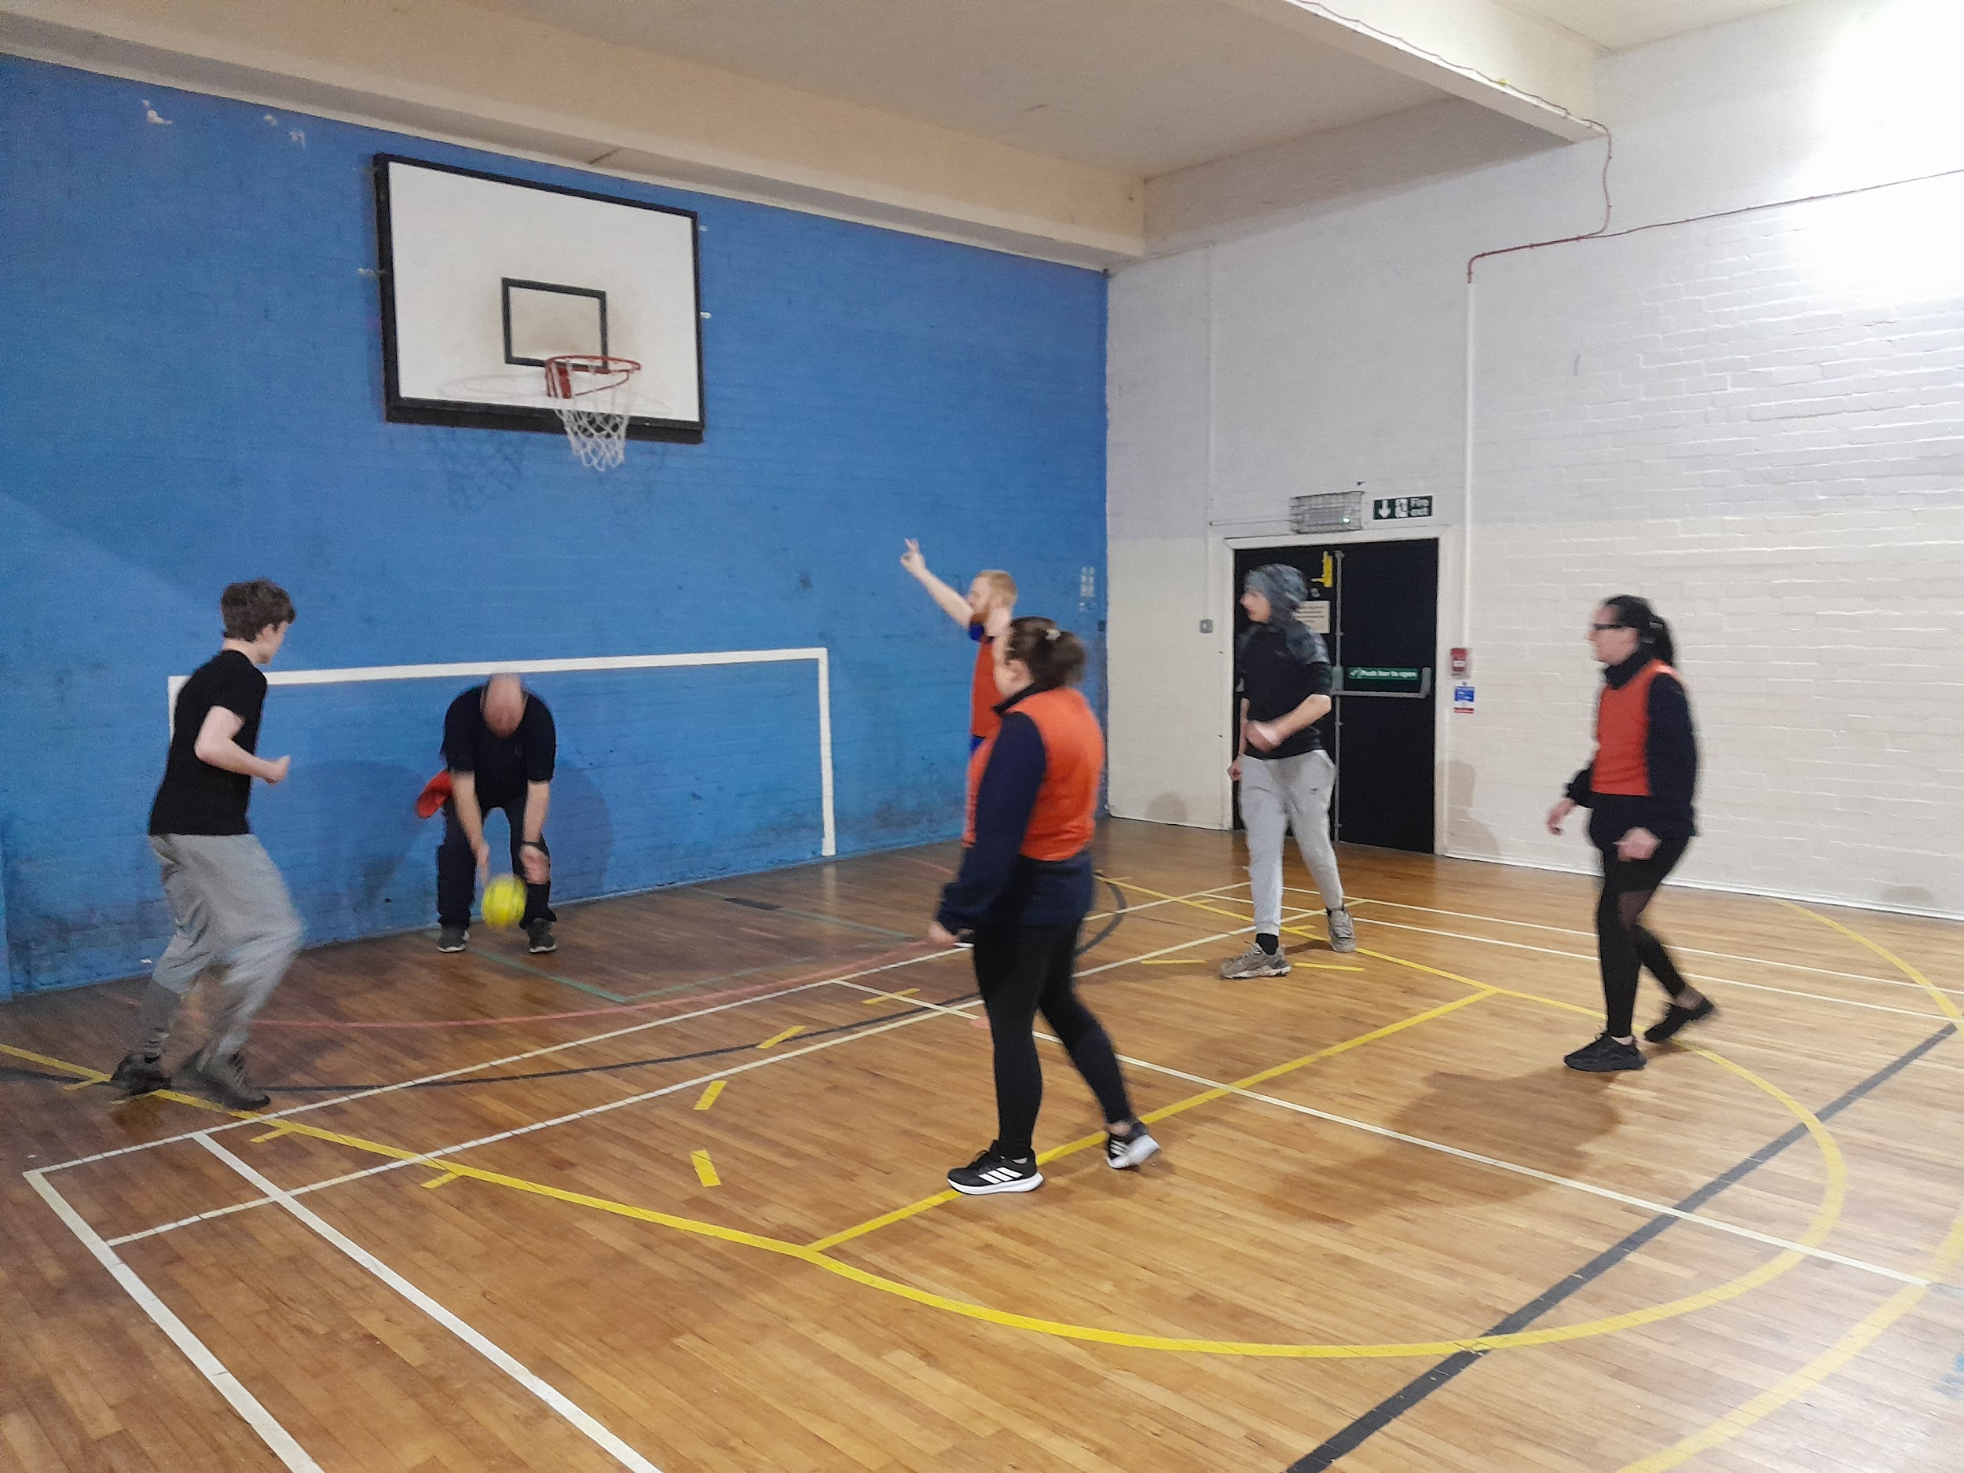
Football match with staff conceding a 5 - 4 defeat

Christmas Houses:
Construction with Mike

Some of our pupils were busy little elves themselves this half term and constructed some lovely little Christmas houses in their Construction lessons.

The houses, made from wood and adorned with intricate Christmas colours were beautiful to behold.

Mike said: “These houses are so cute. The were all made with such care and attention to detail. Our pupils worked really hard to make sure they looked as quaint and Chrismassy as possible.”

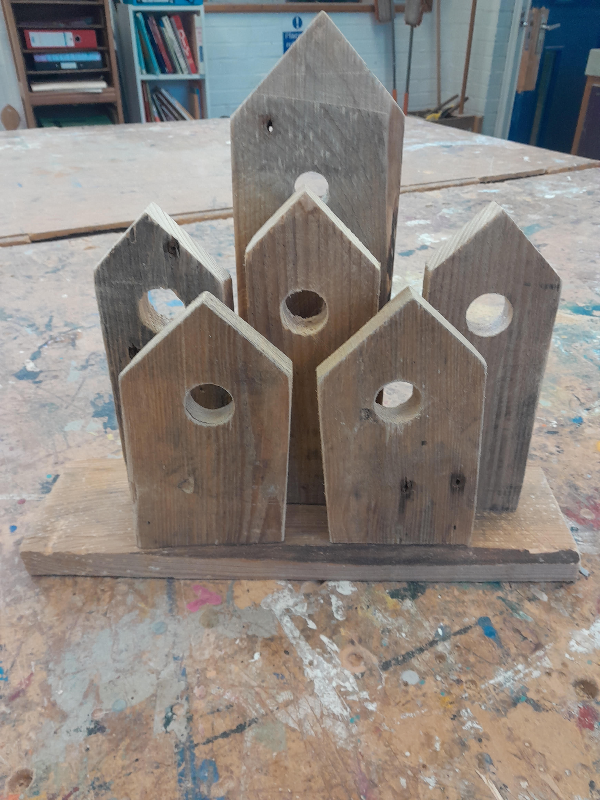
Some of the examples made

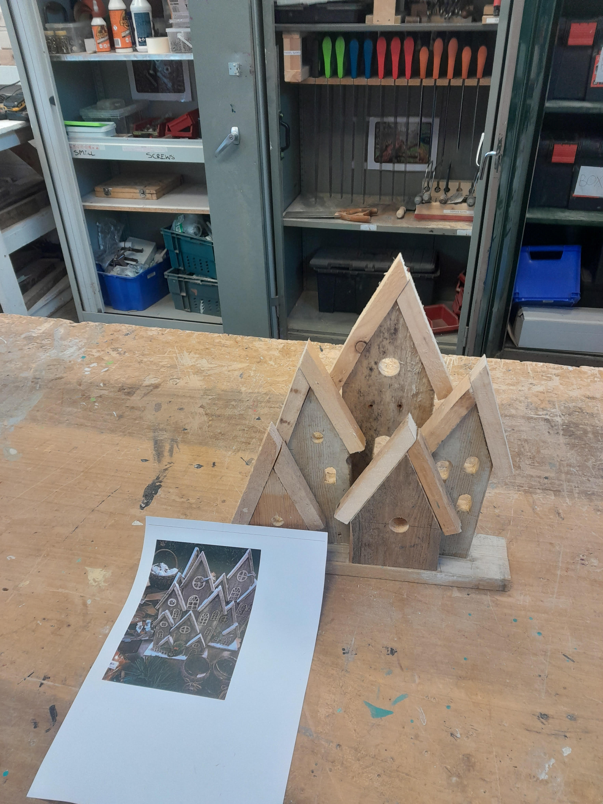
Nearing completion

Supporting Breast Cancer Awareness: School Bake Sale and Football Card Fundraiser

Our school community recently came together to make a meaningful impact by organising a bake sale and football card fundraiser to support breast cancer awareness. This initiative showcased the power of collective effort and the spirit of giving for an important cause.

The bake sale was a resounding success, featuring a delightful variety of homemade treats generously contributed by pupils, parents and staff. Every purchase not only satisfied sweet cravings but also supported the larger mission of raising funds for breast cancer research and support services.

Simultaneously, the football card fundraiser tapped into the enthusiasm for sports with participants eagerly engaging to raise

awareness. This activity not only fostered teamwork and school spirit but also reminded everyone of the importance of community driven efforts in addressing critical health issues.

The staff, pupils and clients were very competitive with the bra pong competition!

Together, these events raised significant funds that will contribute to advancing breast cancer education, early detection programmes and support for patients and survivors. More importantly, they united our school in a shared commitment to making a difference, proving that even small actions can lead to a powerful, positive impact.

We raised £241.50 and John and Sue matched the amount making a grand total of £491.50.

Claudia would like to thank everyone who participated, donated and supported these initiatives. “Your contributions bring hope to countless individuals and underscore the strength of the community in the fight against breast cancer.

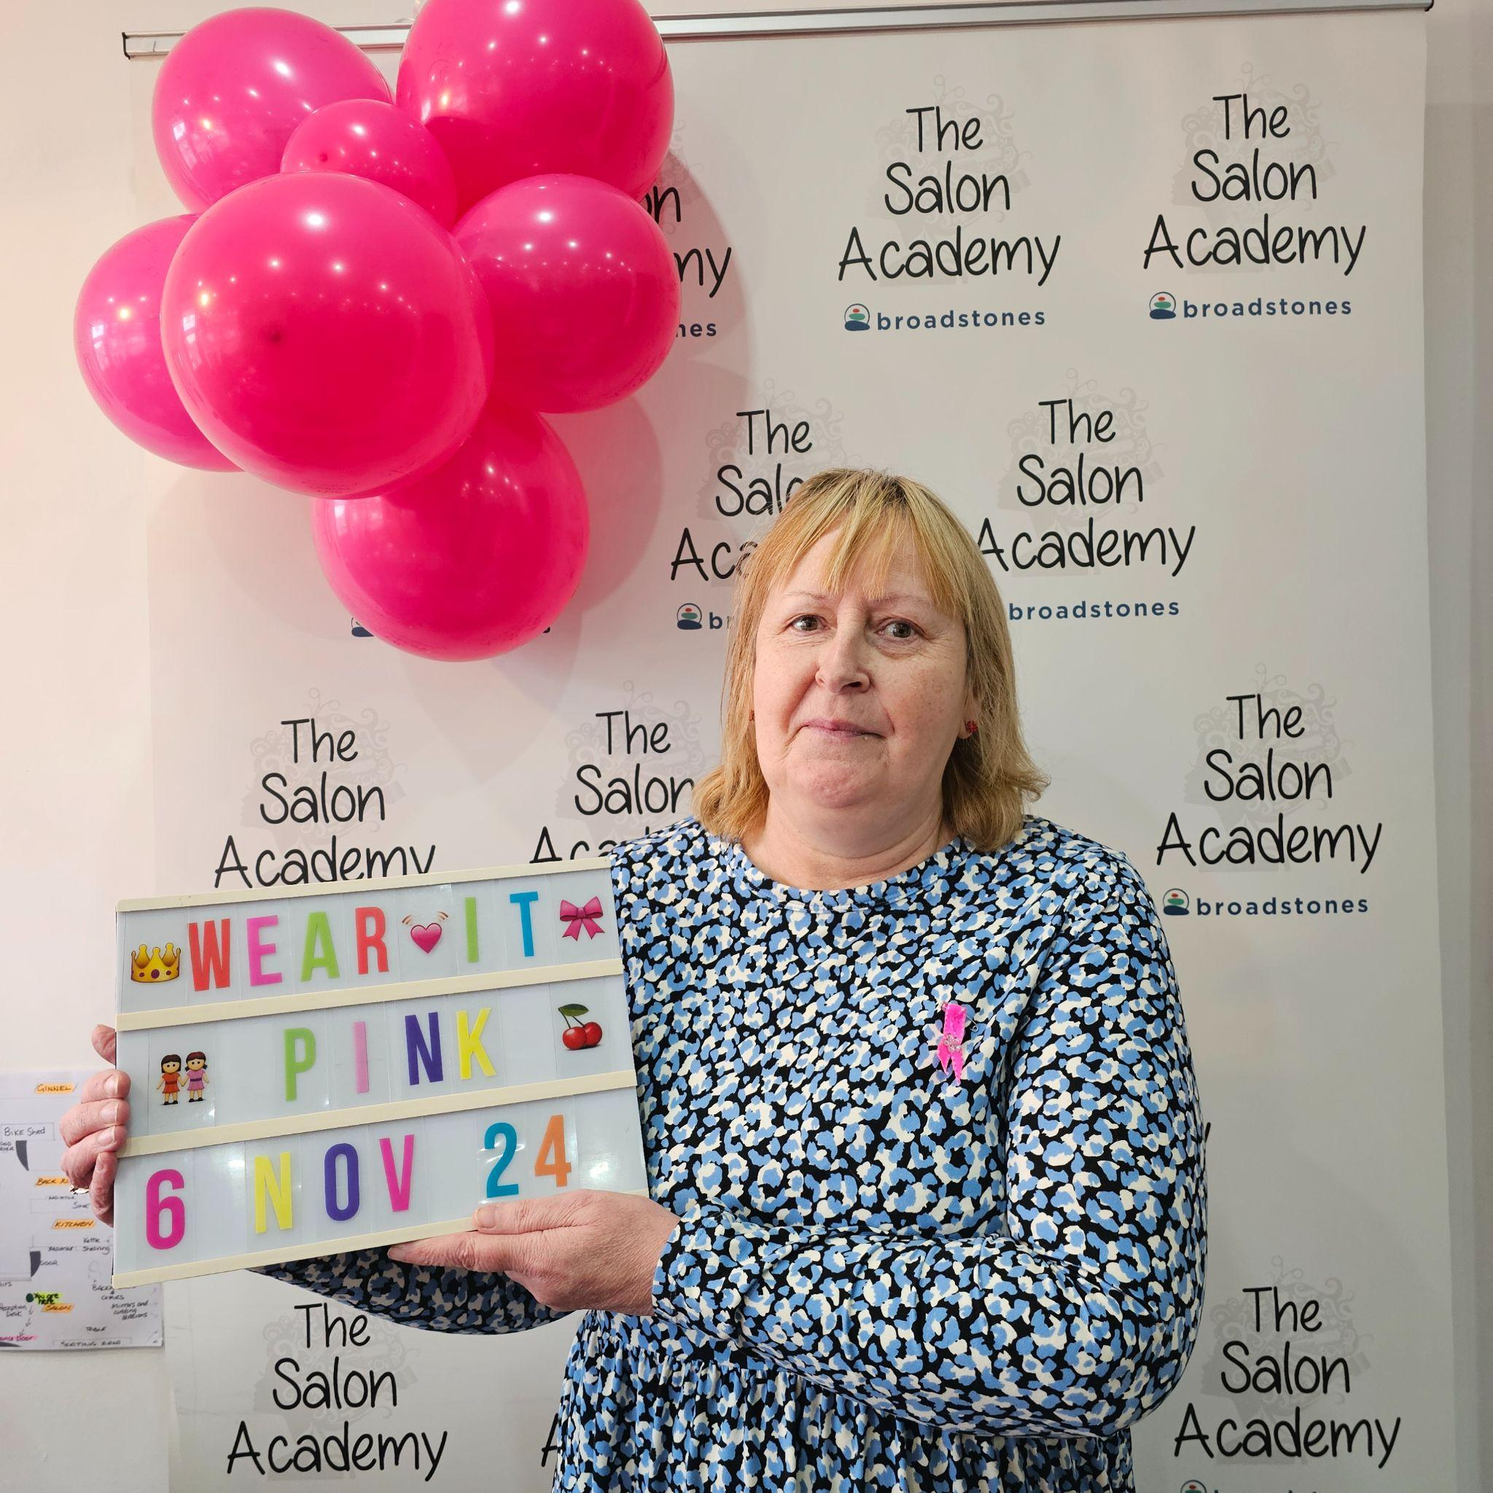

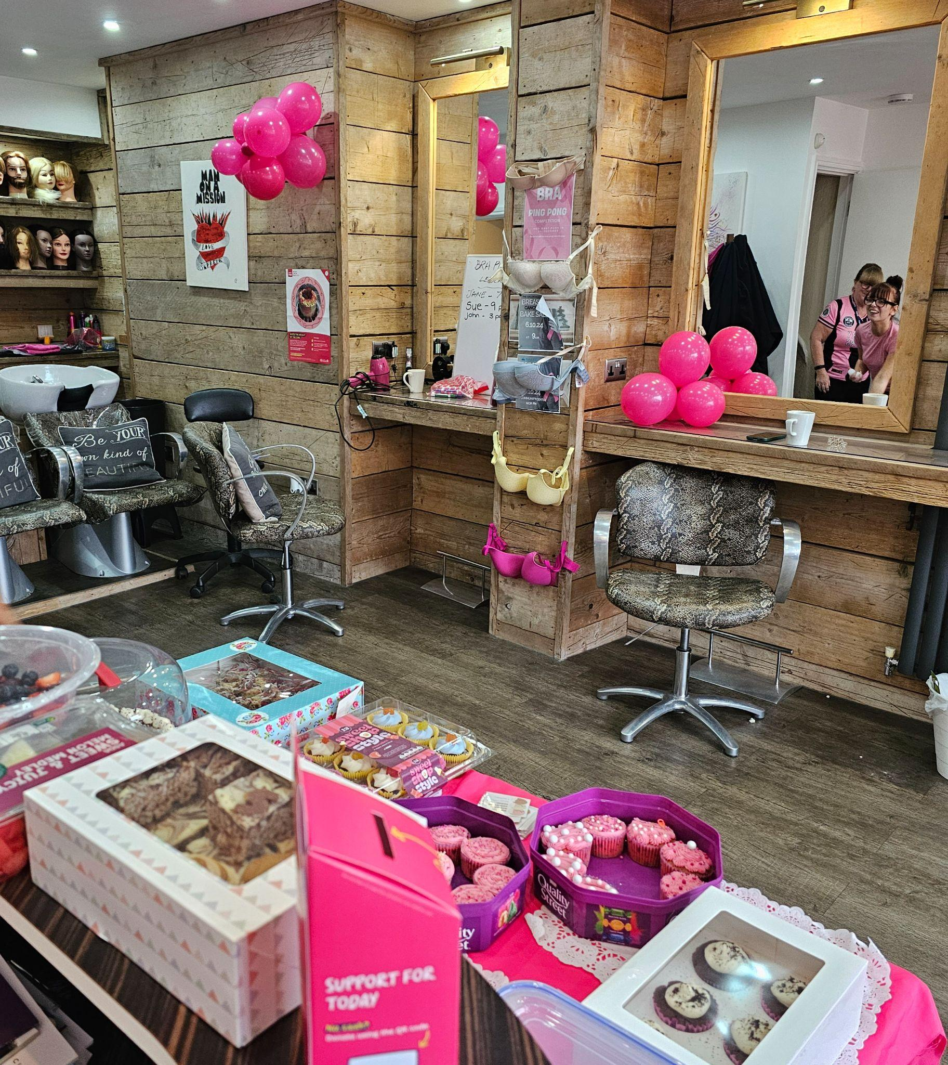

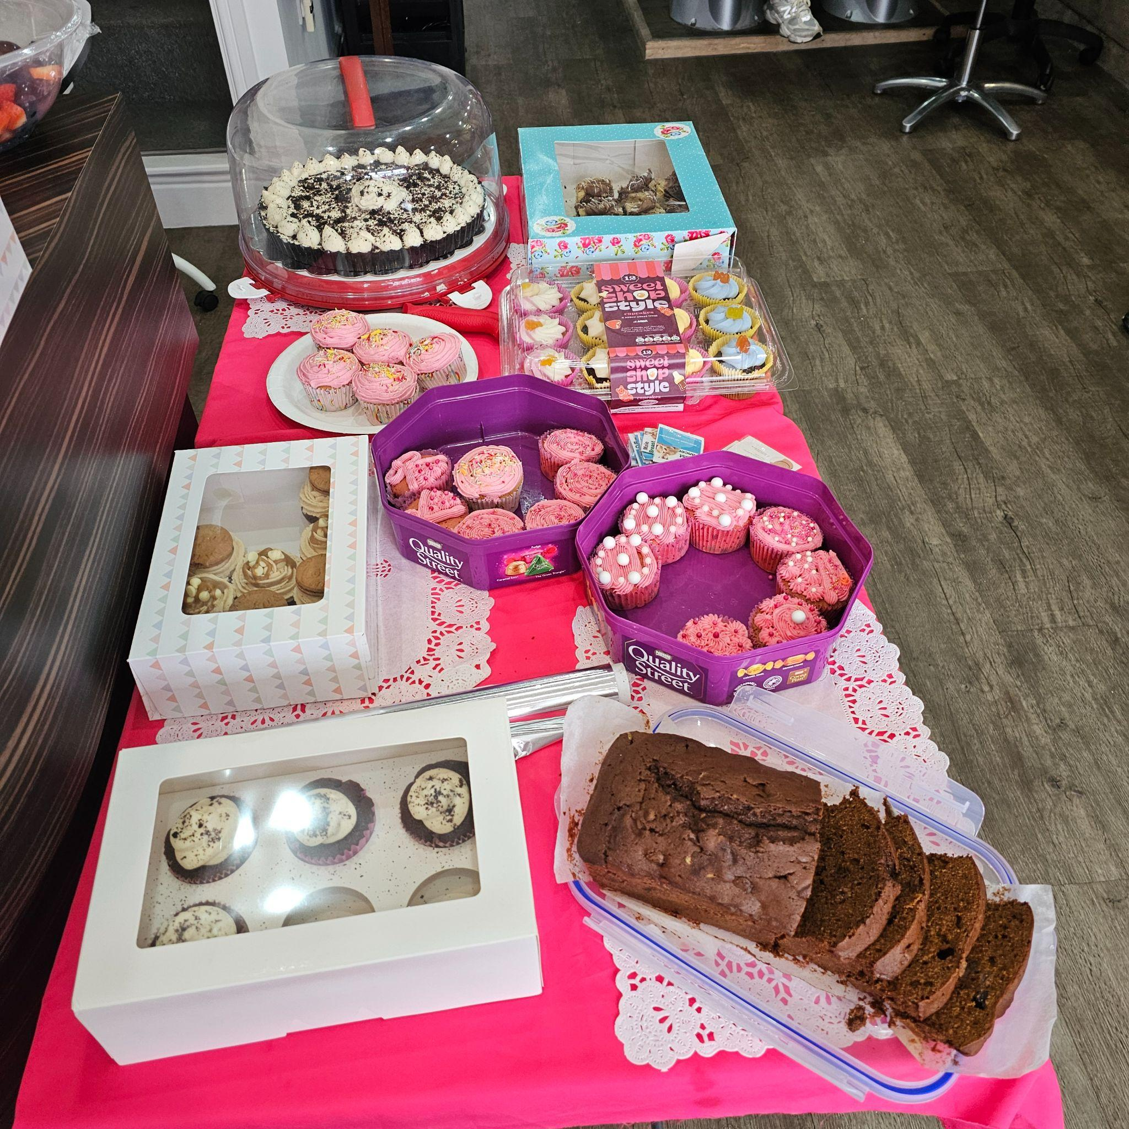

Images depicting the event including the salon and some of the delicious cakes sold

And last, but by no means least - why not have a go at our annual family Christmas quiz?.....

Christmas Quiz

- How many miles would Santa have to run to get home to Lapland from Stockport?
- What is the opening line in Shakin’ Stevens Merry Christmas Everyone’?
- The Snowman was shown on TV for the first time on Boxing Day of which year?
- Which British monarch delivered the first ever Christmas message?
- According to 1946’s Christmas classic It’s a Wonderful Life’ what happens every time a bell rings?
- How many calories does the average Christmas dinner contain?
- How many minutes walking would it take to burn off a selection box containing five chocolate bars?
- How old is Kevin McCallister in Home Alone?
- In Harry Potter and the Philosopher’s Stone, what do the Dursleys give Harry for Christmas?
- How many gifts in total were given in The Twelve Days of Christmas, Christmas carol?

Answers:
- 2,228 miles
- Snow is falling, all around me
- 1982
- George V in 1932
- An angel gets its wings
- Around 1,600 calories
- Around 210 minutes
- 8 years old
- A 50p piece
- 364 gifts

Editor of this edition:
Davina Rothwell davinarothwell@broadstonesschool.co.uk

School Office :
Room 413, 4th Floor, Broadstone Mill, Broadstone Rad, Reddish, Stockport, SK5 7DK

Tel: 0161 820 1974

Co-Editor Charlie , School Ambassador

Useful contact numbers:

KOOTH: (on-line mental
Health support for 11-18
Year olds);
MOSAIC: (Drugs & Alcohol
Services): 0161-218-1100;
MASSH: (Multi Agency
Safeguarding Hub):
0161-217-6028

