
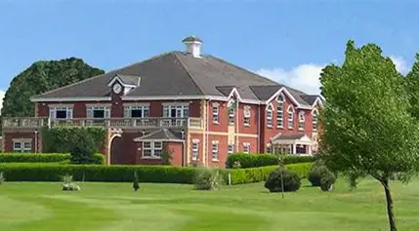

We are looking at holding our fourth Social Event on Thursday 29th January for Parents/ Carers to attend as the previous three have been a great success.
This is a great opportunity for you to meet other Parents/ Carers/ Staff to share experiences, concerns and have your questions answered about your child’s school life.
The Social event will be held at Houldsworth Golf Club, Houldsworth Street, Reddish, SK5 6BN. A light lunch will be provided.
Please confirm your attendance via email with your son/daughter's name to; nicolamassey@broadstonesschool.co.uk or by telephone 07908487568 or 07411601831 this will be greatly appreciated.

If you can please respond no later than Friday 23rd January.
We hope you will all be able to attend and look forward to seeing you there.

Regards
Jackie Simsolo

