
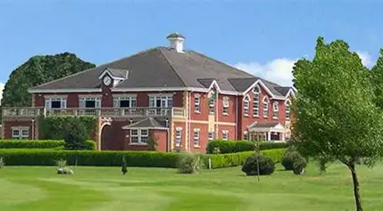

Our next parent social event has been arranged for Wednesday, 6th May 11am until 2pm. We are extending this invite to all parents of On Roll and Outreach Pupils.
At the event we will be giving you vital information including Post 16, so this will be of particular interest if your child is in Year 10 or 11.
The event will take place at Houldsworth Golf Club, Houldsworth Street, Stockport, SK5 6BN and will include tea and coffee on arrival and a light lunch.
Please return no later than Friday 27th March to daniellestradomsky@broadstonesschool.co.uk as we need to confirm final numbers for lunch, thank you.
Regards
Kind Regards,
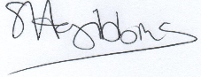
Sue Gibbins, Jackie Simsolo, Edward Gibbins

