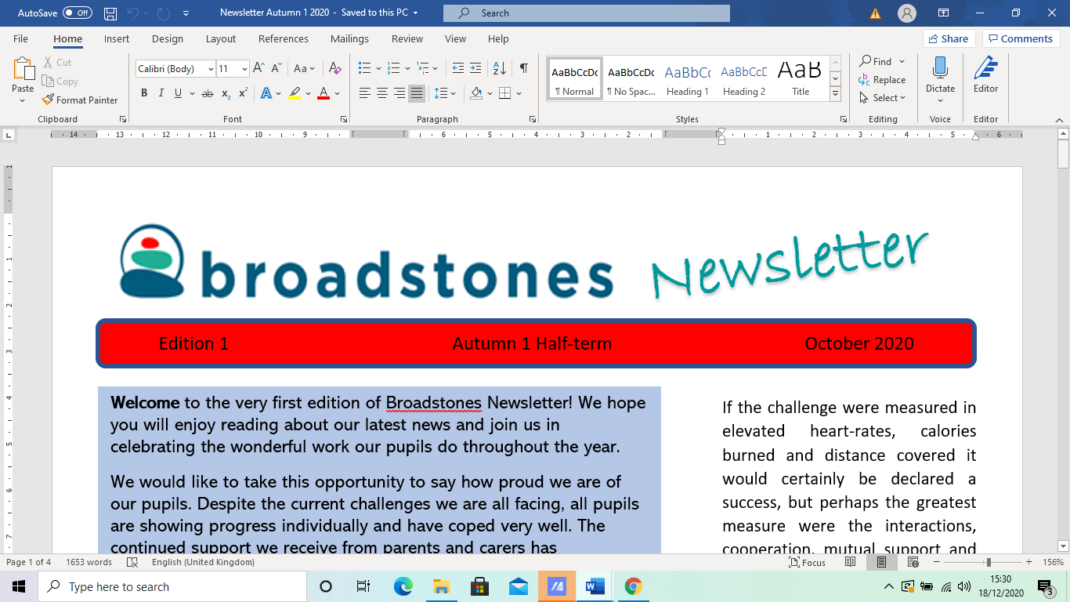

EE15

*Edition 16* Summer 1 May 2023

***Welcome to***

***Broadstones May edition newsletter!***

*It’s been a hectic half term with important exams taking place as well as pupils completing coursework that will ensure they receive the qualifications they have worked so hard for this year.*

*As well as all the hard work, we also look at some of the less stressful and more enjoyable endeavours of our staff and pupils!*

*We hope you enjoy this issue which covers (to name but a few) Winton’s Wish Recommendation;* *Down Syndrome Day 2023 charity fundraising event; plus the usual curriculum area updates and much, much more!*



There are 3 public Bank Holidays this month, so let’s hope we see the sunshine and avoid the rain.

**Half Termly Spelling Competition**

This half term’s winner is Roman who scored an impressive 12 out of 13!

Roman received the £10.00 Amazon voucher and as a result of his brilliantspelling ability, we have nowhad to up the ante this time round with even harder words on this term’s test!

*** Well done Roman ***

**Wellbeing Support Recommendation: Winston’s Wish**

Winston's Wish is a charity offering support to young people and children who have experienced loss and bereavement or dealing with grief. Any young person from pre-school age up to 25 can access their services.

They offer practical support, advice and counselling to bereaved young people and their families.

They provide a free Helpline, for advice, guidance and support following a bereavement-

phone: 08088 020 021

Text: 'WW' to 85258

Email: ask@winstonswish.org

They provide an online chat for young people through their website from 3 - 8pm.

**Science with Claire**

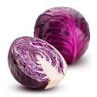

Claire’s been busy carrying out experiments using red cabbage.

Some pupils have been extracting the indicator from vegetable best known in pickle making; an indicator tells us whether we have an acidic, alkaline or neutral substance. For example, vinegar is acidic, water is neutral and sodium bicarbonate is alkaline.

Did you know that red cabbage turns red in acid, purple in neutral substances, yellow or green in alkaline substances?

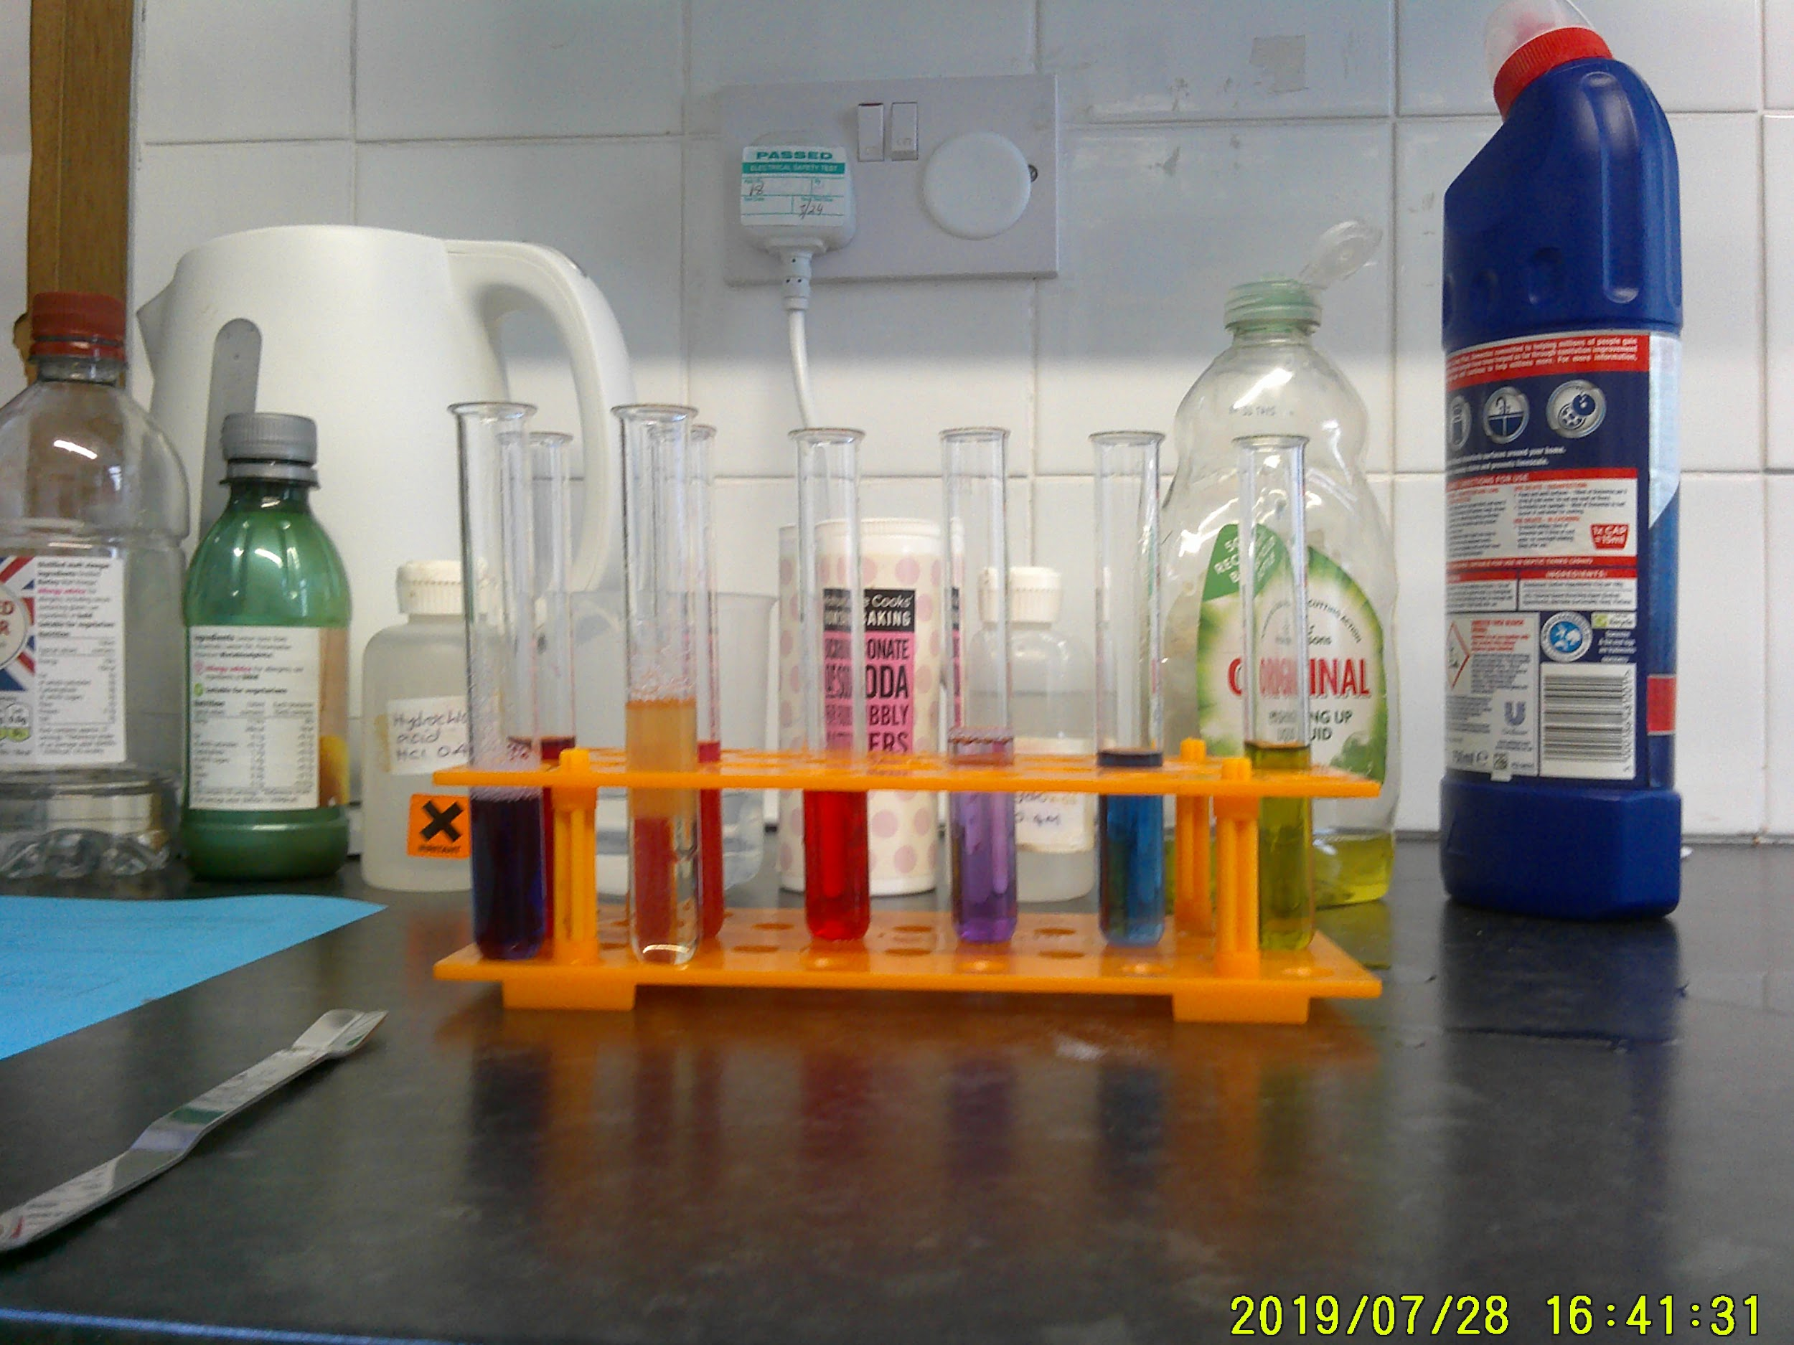

**Robyn’s red cabbage experiment**

**Attendance Bowling Reward Trip**

Nicola, our Attendance Officer rewarded some of our learners with a trip to the bowling alley this term.

The lucky pupils got to show off their strikes and spare moves, turkey and badger (I kid you not); splits and pockets, etc.

A lovely afternoon was had by all with Cadey and JayJay emerging as best on the day players, winning both their lanes and thrashing all saff in the process.



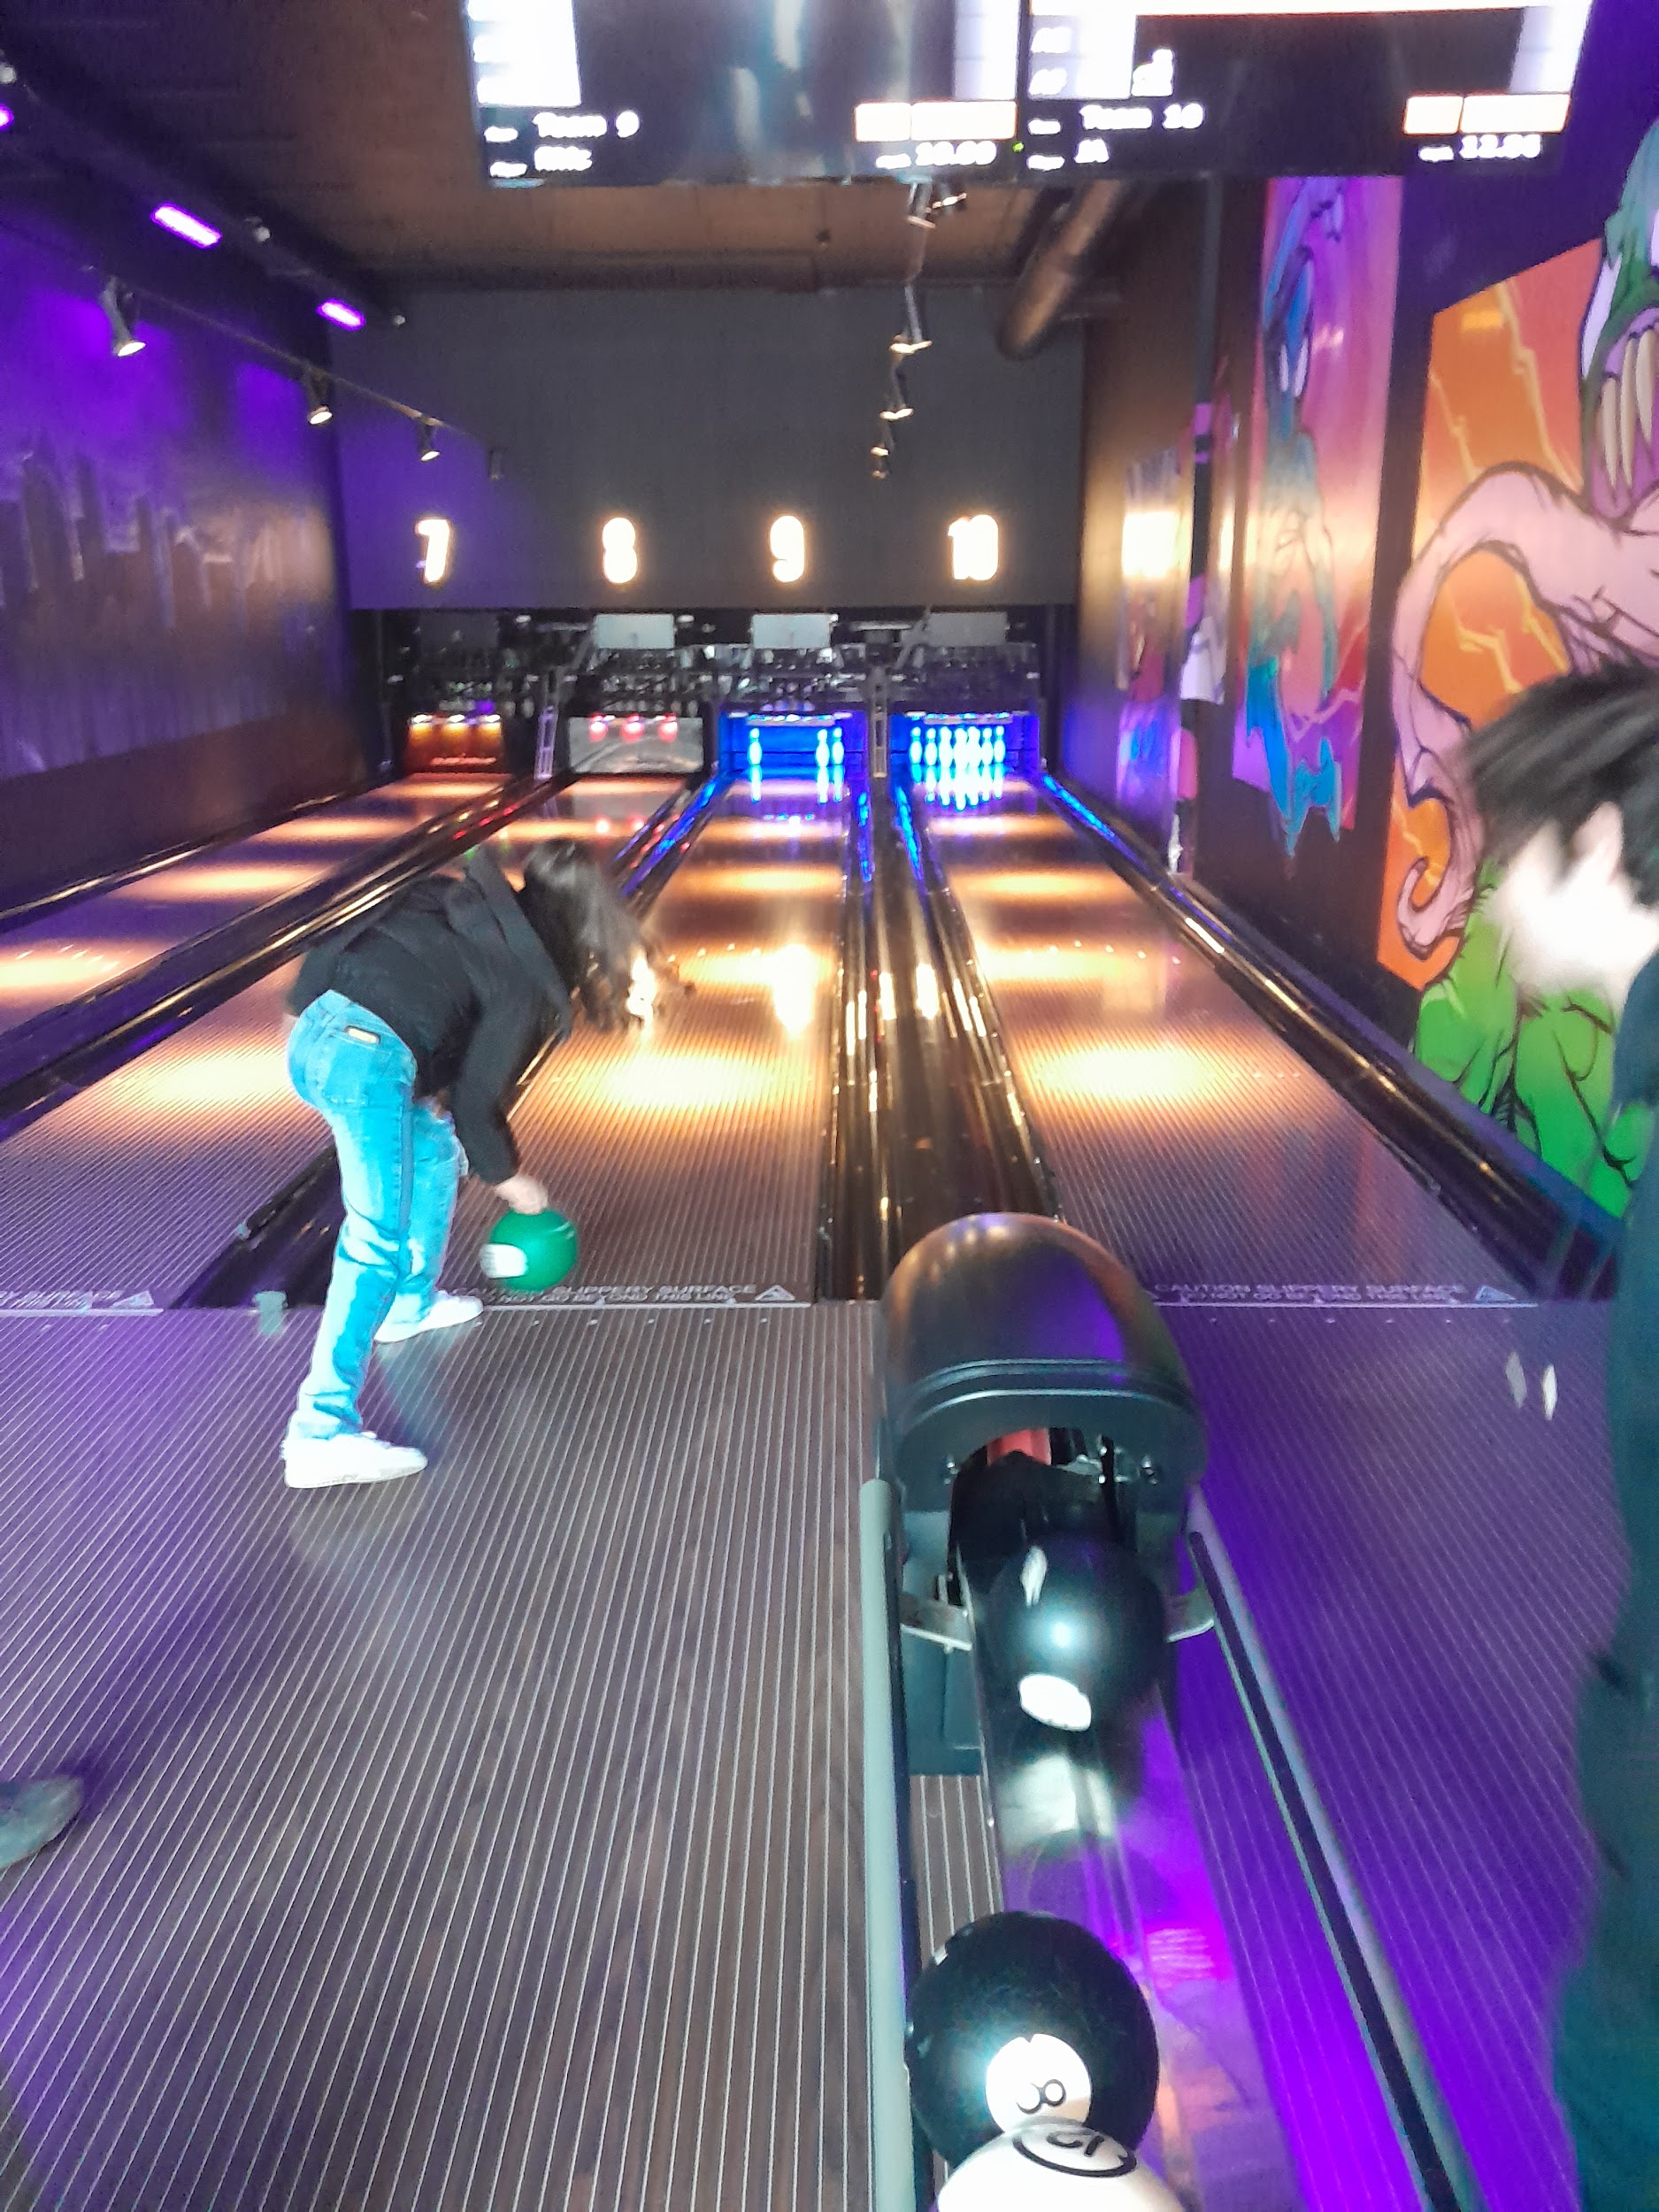

**Two of our learners showing off their bowling skills**

**Charity Fun-Raising with Alex**



Alex, our Bike tutor, organised a fundraising event for Down’s Syndrome.

He asked all staff to wear odd socks on the day and managed to raise £55.00 for charity, which was equalled again by John and Sue to bring the final total to £155.00!

Alex said: ‘This opened my eyes to a whole different outlook on life and understanding of disabilities.’

Well done, Alex. We encourage our pupils and staff to learn about different types of disabilities to raise awareness and to help create a sense of solidarity and understanding.

**Work Experience**

Some of our Yr 11 pupils have been enjoying their work experience placements this half term.



Notably - Chloe is thrilled to have been offered a place at her favourite football club - Stockport County!

County are doing brilliantly at the moment as we know, and Chloe is loving learning what goes on behind the scenes at the club.



Ollie and Keegan have also been supporting Re:dish by creating signage and adverts for their local shop.



**Half Term Quiz**

1. On what calendar day is May Day actually celebrated?
2. What type of dancing is usually performed in conjunction with May Day celebrations in England?
3. Is May Day a British or international event?
4. What is your sign of zodiac if your birthday is in May (either of two months)
5. Which product by Steve Jobs, Apple’s chief executive, was introduced on 7th May 1998?

Editor of this edition:

Davina Rothwell davinarothwell@broadstonesschool.co.uk

School Office :

Room 413, 4th Floor, Broadstone Mill, Broadstone Rad, Reddish, Stockport, SK5 7DK

Tel: 0161 820 1974

**Useful Contact Numbers**

KOOTH: On-line mental health support for 11–18-year-olds https://www.kooth.com

MOSAIC: (Drugs & Alcohol Services: 0161-218-1100

MASSH: (Multi Agency Safeguarding Hub: 0161-217-6028

*Don’t forget that you can also speak to any member of staff at Broadstones during school hours, if you need advice or guidance about things that might be worrying you.*