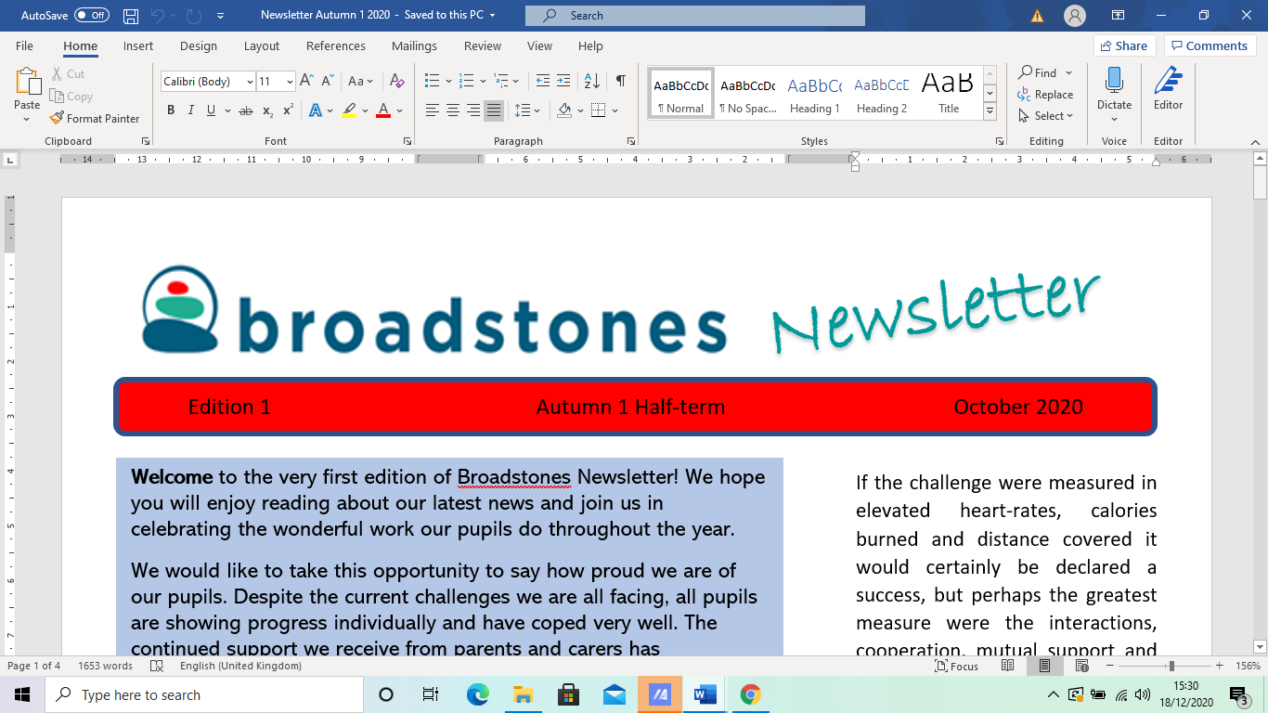

EE15EEdition 19E

***Welcome to our first 2024 (February half- term) newsletter.***

*On behalf of everyone at Broadstones, we would like to wish you all a very, very Happy New Year!*

*It’s been a short half term - only 5 weeks long but nevertheless a busy one.*

*We bring you up to date with new information; then with our usual features such as: some of the goings-on in particular curriculum areas; feedback information from recent events; and last but by no means least - What’s on the Horizon?*

***\*\*\*\*\****

**New Staff**

Let’s start by introducing a new member of staff. Claudia from the salon:

“We are thrilled to share

some exciting news with you. We have a new addition to our team who is set to elevate The Salon Academy and boost confidence in our pupils!

Lucy is a talented and experienced hairdresser, who comes with a wealth of knowledge and a passion for helping pupils reach new heights in their careers.

Lucy brings extensive experience from running her own salon - making her the perfect mentor for our aspiring hairstylists.

With a keen eye for detail and a commitment to staying updated on the latest trends and techniques, Lucy is dedicated to empowering our pupils with the skills and knowledge needed to thrive in the dynamic world of hairstyling.”

Welcome Lucy!

**Arthur in Japan**

Our very own Arthur has taken a short sabbatical leave to explore in Japan! He will be back with us early in the new half term.

During his time there, he’s sent us a weekly blog - wonderfully worded travel writing, that’s been shared and discussed amongst pupils and staff, of his exciting adventures of a lifetime in The Land of the Rising Sun.

We’ve read about: his hectic 30-hour journey to his destination; his ample but rudimentary accommodation; the modern and highly developed transport systems; and been captivated by his vivid, colourful descriptions depicting the countryside and towns of Kyoto, Osaka and Bunraku.

Arthur has been eating exciting foods such as: “gooey octopus dumplings, suchet, oyster and many other Eastern delights…

…as well as experiencing the hustle and bustle of the busy, blustering towns to the “profound sense of quiet”

of the countryside, especially when visiting the ancient temples and sacred burial sites - full of stone obelisks, and guarded by the statues and shrines to the god, Jizo.

In Arthur’s words, the temple of Otonagi Nenbutsu-ji is: ‘“special”, a place he describes as: “Like being transported to another world, away from the present day, almost away from humanity.”

It is clear that Arthur is thoroughly enthralled by his once-in-a-lifetime experience, and we look forward to his return so he can share his exciting, exquisite exploits in more detail.



**Statues and shrines to the god Jisuo (protector of travellers and of children)**



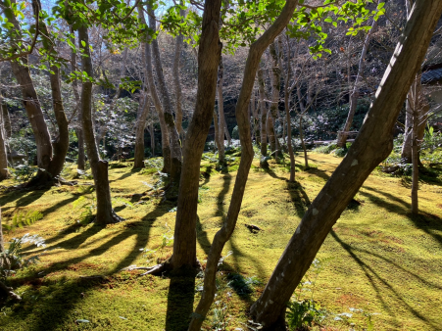

***T*he contrast between city and rural life is captured in these contrasting images captured by Arthur**

**Parents Social Day**

For the second year running, we held our annual Parents Social Day in the Midway in Stockport.

On the agender (including great food) was looking at pupils’ progression and attainment; looking at the prospects for post-16; information on the planned resilience team training for pupils; as well as the wilderness team activities planned for OutReach pupils.

A very successful time was had, with a great turnout, giving parents and carers the chance to speak to staff, speak to each other and speak about anything at all relating to their child’s education.

**Mental Health Week**

Did you know that from 5th to 11th February is Children's Mental Health Week?

This is a national event aimed at empowering young people, equipping them with the tools needed for great mental health, and encouraging them to voice or even just air any concerns.

Staff were encouraged to liaise with pupils, listen carefully to their contributions and carry out specially designed activities to give them advice and strategies to help with mental health.

For more information, ideas and resources log onto: [*https://www.childrensmentalhealthweek.org.uk/*](https://www.childrensmentalhealthweek.org.uk/)

**\*\*\*\*\***

**PSHE - Sexual Health**

All pupils have received sexual health education this half-term.

A representative from Central Youth gave advice on relationships; contraception; consent and the law.

This service is available *f*ree of charge to anyone up to the age of 25, where they can access confidential advice and support from sexual health advisors any time.

**English with Davina**

Just before Christmas, Bobby won the spelling competition. Although, to be fair, it was an extremely close competition with Charlie and Brooke just marginally missing out on the £10.00 Amazon voucher.

Spelling at Broadstones is definitely on the up.

However, just to shake things up a bit, this half term’s competition in English has been changed to a writing challenge.

Pupils were asked to write a short story (or poem) and I am pleased to say that the quality of writing was absolutely fantastic.

It’s great to know that our pupils have fantastic imaginations (if somewhat dark, it must be said) and feel confident enough to compete against each other, albeit in a light-hearted competition.

After a very difficult judging session, a winner was chosen. All stories were judged anonymously (authors’ identities not revealed to staff and pupils) and I am pleased to announce the winner - Bobby received the £10.00 Amazon voucher.

**Science with Claire**

Some pupils have been learning how heat is transferred through liquids and gases.

We have used the chimney in the photo below to show how this happens.

The candle heats the air around it. The hotter, less- dense air particles rise out of the chimney.

The colder air is more dense and so is drawn down the chimney to replace the space left.

This is called a convection current and is how a chimney works and how heat is transferred from a radiator.

The smoke from the lit paper is drawn into the chimney so that you can see the convection current.

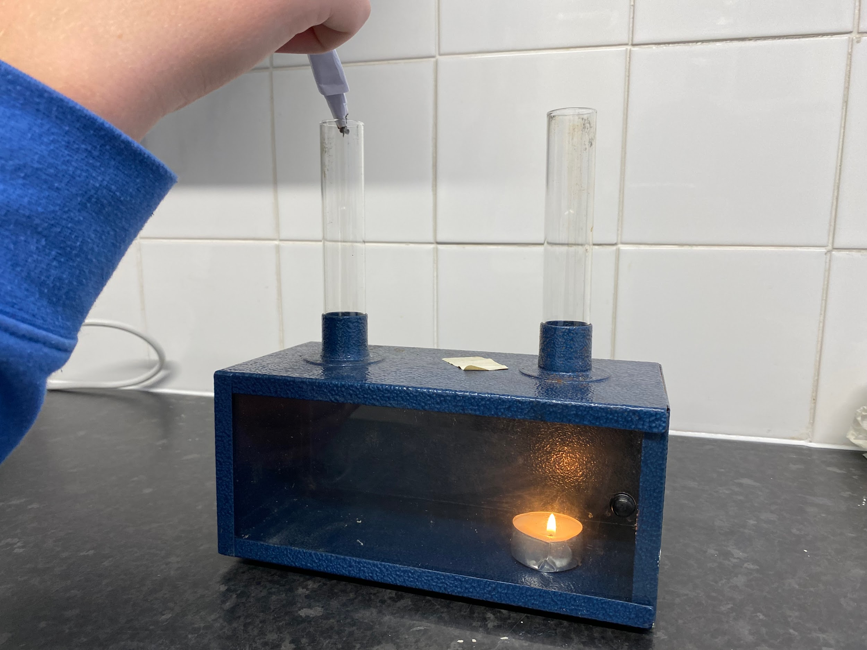

**Simulator showing how a chimney works**

**Hair and Beauty**

**With Claudia**

Studio Wigs: Claudia attended the Alopecia meet-up session in Manchester at the end of January.

The group had insightful discussions on wig care and maintenance, current trends in wig design, and the evolving landscape of wig fashion.

She exchanged ideas and experiences, fostering a sense of community among the diverse group of attendees.

Claudia invited all attendees to a free wig consultation on 29.2.24 and explained our wig dropoff and maintenance service.

Claudia wishes to remind you all that: “The Salon Academy accepts pre-owned wigs to re-gift. You can drop off wigs during school times.”

These wigs are recycled, restyled and donated to people in the community that need them.

**

**Some of the ready to wear wigs produced at the salon**

**\*\*\*\*\***



**And finally…**

**What’s on the Horizon?**

*More information is to follow on resilience team training and the Wilderness Tribe activities - all in the pipeline.*

*Also, the next exciting instalments of Arthur’s Japanese adventures.*



**Useful Contact Numbers**

**KOOTH: (on-line mental**

**Health support for 11-18**

**Year olds);**

**MOSAIC: (Drugs & Alcohol**

**Services): 0161-218-1100;**

**MASSH: (Multi Agency**

**Safeguarding Hub):**

**0161-217-6028**