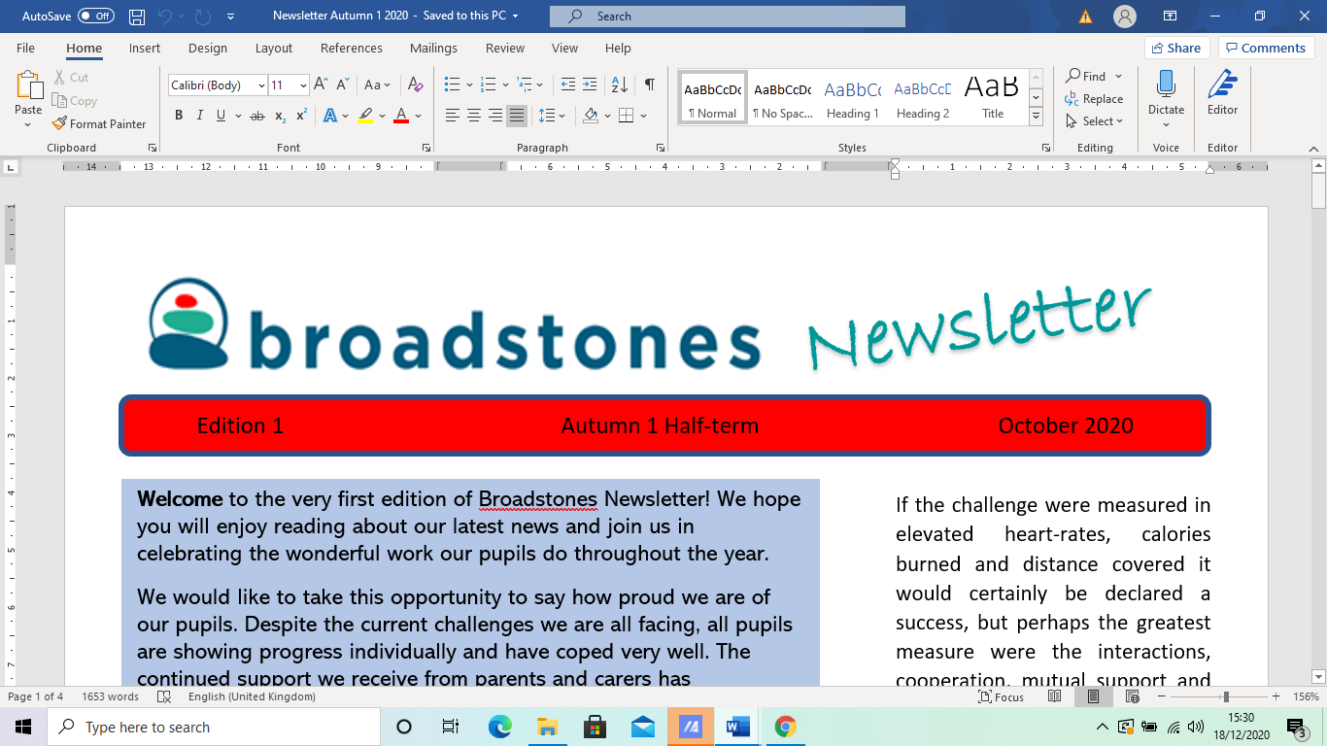

EE15EEdition 19E
Edition 19 Autumn 2 December 2023

Welcome to Broadstones Christmas edition newsletter. And let me begin by wishing you all, on behalf of everyone here at Broadstones, a wonderful Christmas and a very Happy New Year!

I must begin by informing you of some very bad news, however.

It is with great regret that we announce the sad passing of Maxine Mottershead, a previous staff member at Broadstones, who has sadly passed away.

In her memory, money was raised for the British Heart Foundation by staff and the school. She will be missed and remembered fondly.

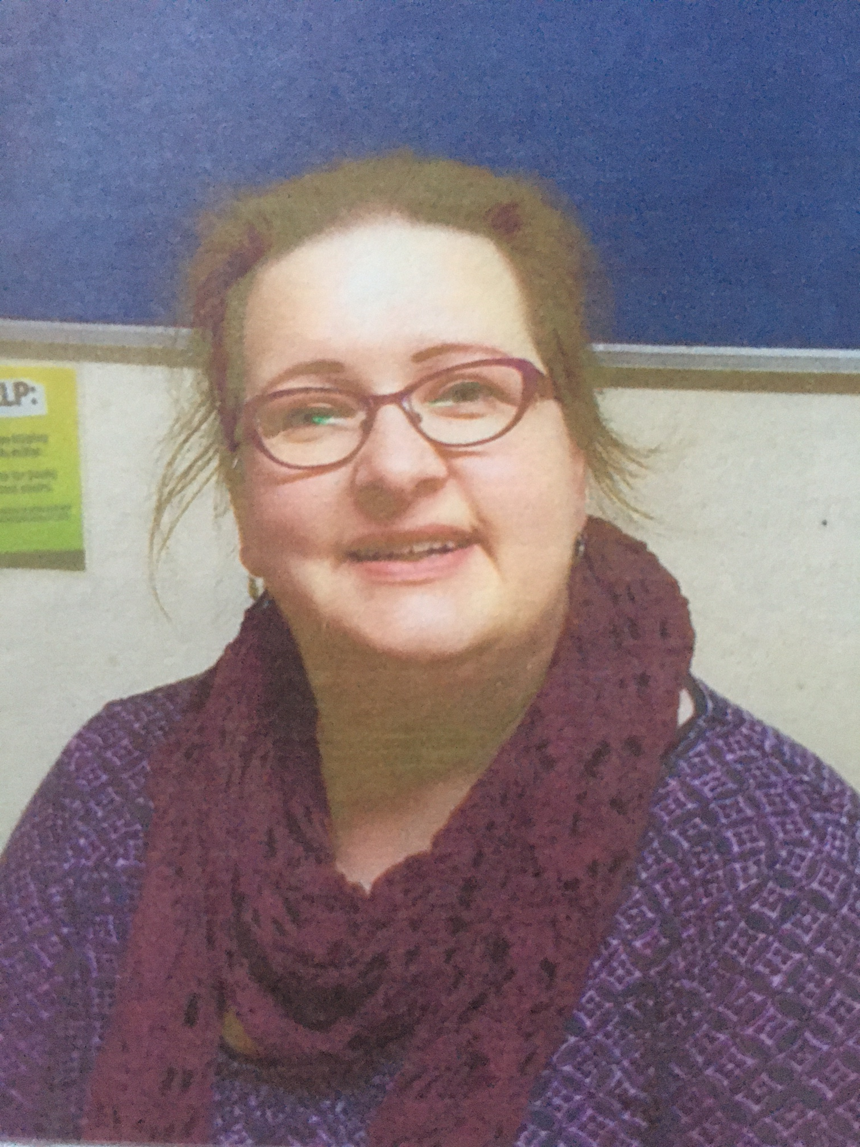



It’s been a busy half term with lots going on, so read on to find out about: our recent Ofsted visit; some of the highlights of the school term in areas such
as enrichment and PSHE; we include some of the goings-on in our usual curriculum features. We include a new section called What’s on the Horizon? This details just that - new initiatives designed to enrich our pupils’ experiences even more; and finally and by no means least - our plans to celebrate Christmas!

Ofsted Inspection

We were treated to an Ofsted inspection at the end of November that lasted three days.

Without a doubt, the inspection was deep, thorough and somewhat
stressful (as all Ofsted inspections are).

However, our staff and pupils did our school proud, leaving the inspectors in no doubt that we really are achieving our goals in delivering a great education in a caring and nurturing environment.

We have just received the official feedback and this can be found on our school website.

****
External Verification Visit

Just to keep us on our toes even more, one of the examination boards we use - Gateway sent in their own verifiers on a routine visit to check our pupils’ work and the school’s administrative practices.

This was a day-long visit, involving scrutiny of all our subject areas (curriculum areas), and we are pleased to report, that, as expected, their findings confirm we are delivering an appropriate range of subjects; carrying out assessments correctly and in line with government regulations; and that all our documentation is up-to-date and accurate.

*****
Staff Well-Being Day
Thanks to Sue and John for our annual staff Well-Being Day.

The day commenced with a lovely breakfast for all staff at the Tea Rooms at The Plaza, Stockport.

Staff were then treated to a lovely gift voucher to go off and treat themselves in Stockport.

As well as shopping, also on the agenda was site-seeing for pleasure and for inspiration for activities to use with our pupils, centred in and around Stockport town centre.

Did you know that Stockport has plenty to offer, such as:

The Plaza Theatre, The Dungeon, Air Raid Shelters, Staircase House. Hat Works, Robinsons Brewery Visitors Centre, Lowry’s Crowther Street, not to mention all the parks and nature attractions plus lots, lots more….

*****
Science
With Claire

Claire has been busy this term working with some pupils to show them how working with a model can help explain the dissolving process.

Pupils measured 50ml of dried peas to represent the solute (substance) that is dissolving and 50ml of sand to represent water.

They had to predict what the total volume would be and Claire was not surprised by the usual answers that she received. However, she wasn’t prepared for one pupil who, for the first time in Claire’s living memory, got it spot on! Claire said:

One Pupil made a very good prediction and realised that the sand would go in between the peas so the total volume would be less than 100ml!. He is the first Broadstones pupil to ever give the correct reason for his hypothesis.”

Brilliant work.

Other pupils had been finding out if hot chocolate cools faster with or without marshmallows on top.

The result was that: indeed it cools slower with marshmallows on top as they act as a source of insulation, keeping the hot chocolate warmer for longer.

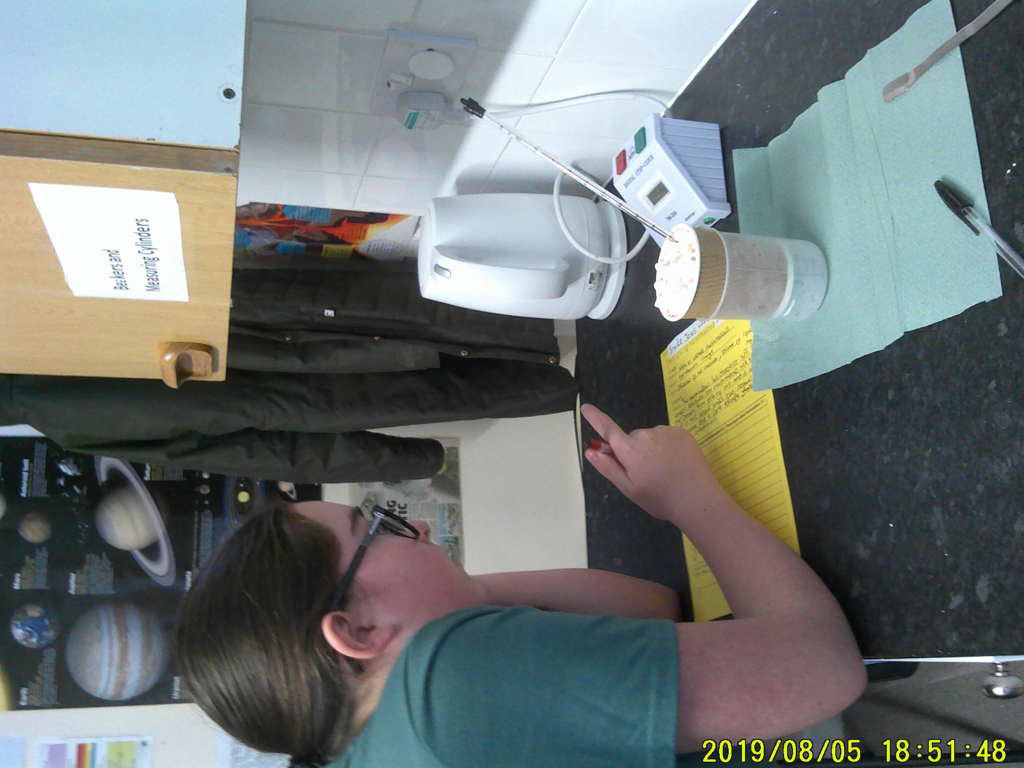
Here’s Brooke carrying out the marshmallow experiment

*****

Bikes with Alex:
Brinnington Bike Fest

On Tuesday the 28th of November, the Big Local, Brinnington, and Life Leisure Brinnington, hosted the Brinnington Bike Fest.

Its aim was to promote all the benefits of active travel as part of the newly launched Bee Network.

As part of this event, junior school children from Brinnington took part in a competition. They were asked to say why they would like to win a bike and to say where they intended to ride the bike if they won one.

Nine bikes were awarded (seven refurbished by Broadstones), which were in turn awarded to the winners by Dame Sarah Storey – a multi-gold medalist Paralympian and the Active Travel Commissioner for Greater Manchester.

The bikes were double- checked by Matthew Hutchinson, workshop manager for Never Mind The Bike Shops and we were proud to hear that our bikes, refurbished by our own pupils were: “The best refurbished bikes we have seen from the school.”

Sarah Storey thanked the Broadstones School team and pupils for the great job they did on the bikes and signed a Broadstones School flag for us!

Dave, Deputy Head of Broadstones said: “”Hopefully the bikes provided to the competition winners will inspire these youngsters into life-long cycling.

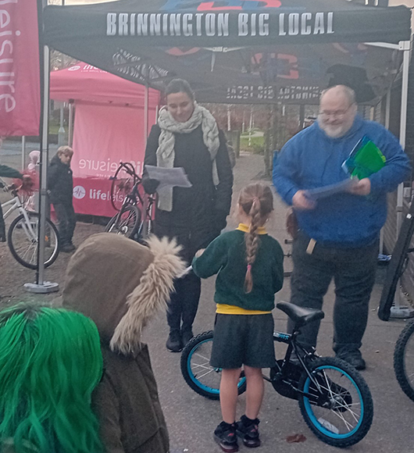
A Bike Fest winner

*****

PSHE

There’s been a lot going on in PSHE this term.

We’ve had MOSAIC in to talk to our Year 10 groups about drugs, alcohol and how to stay safe.

There’s been walks down the vale, for example the Year 11s went down during one lesson; turns out Bobby, Year 11 is something of a horse whisperer.

Pupils also fed pigeons, ducks and geese as well soaking up the atmospheric natural environment, provided by Reddish Vale on a cold but lovely December day.

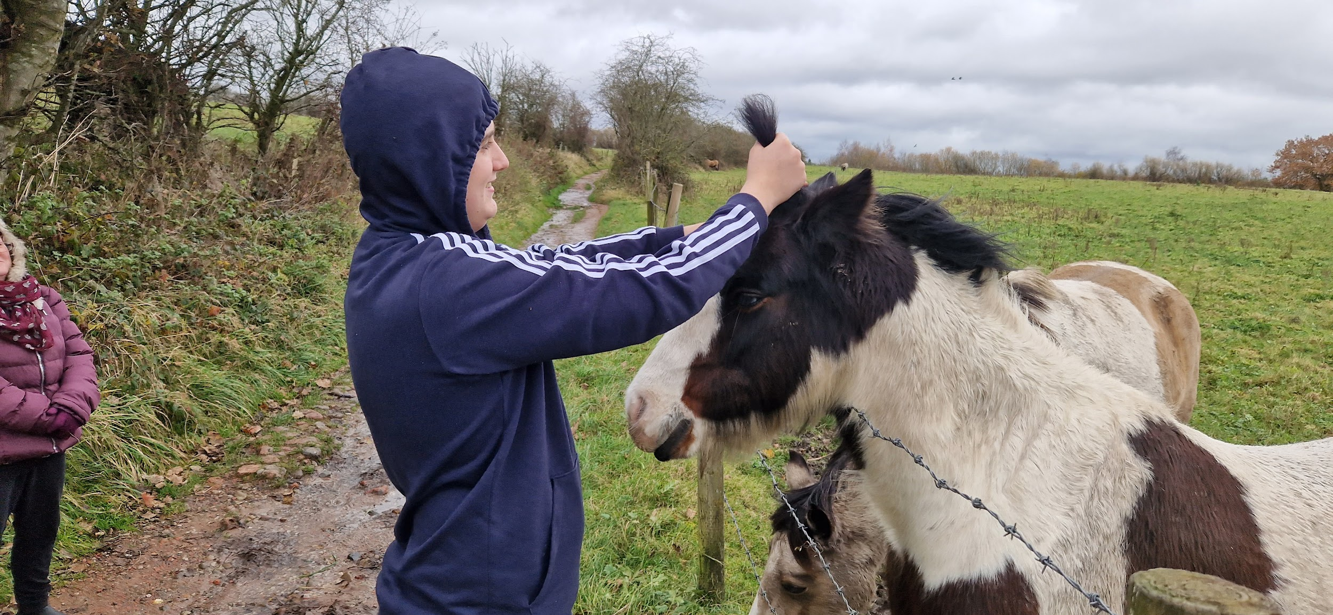
Bobby tidying the horse’s mane

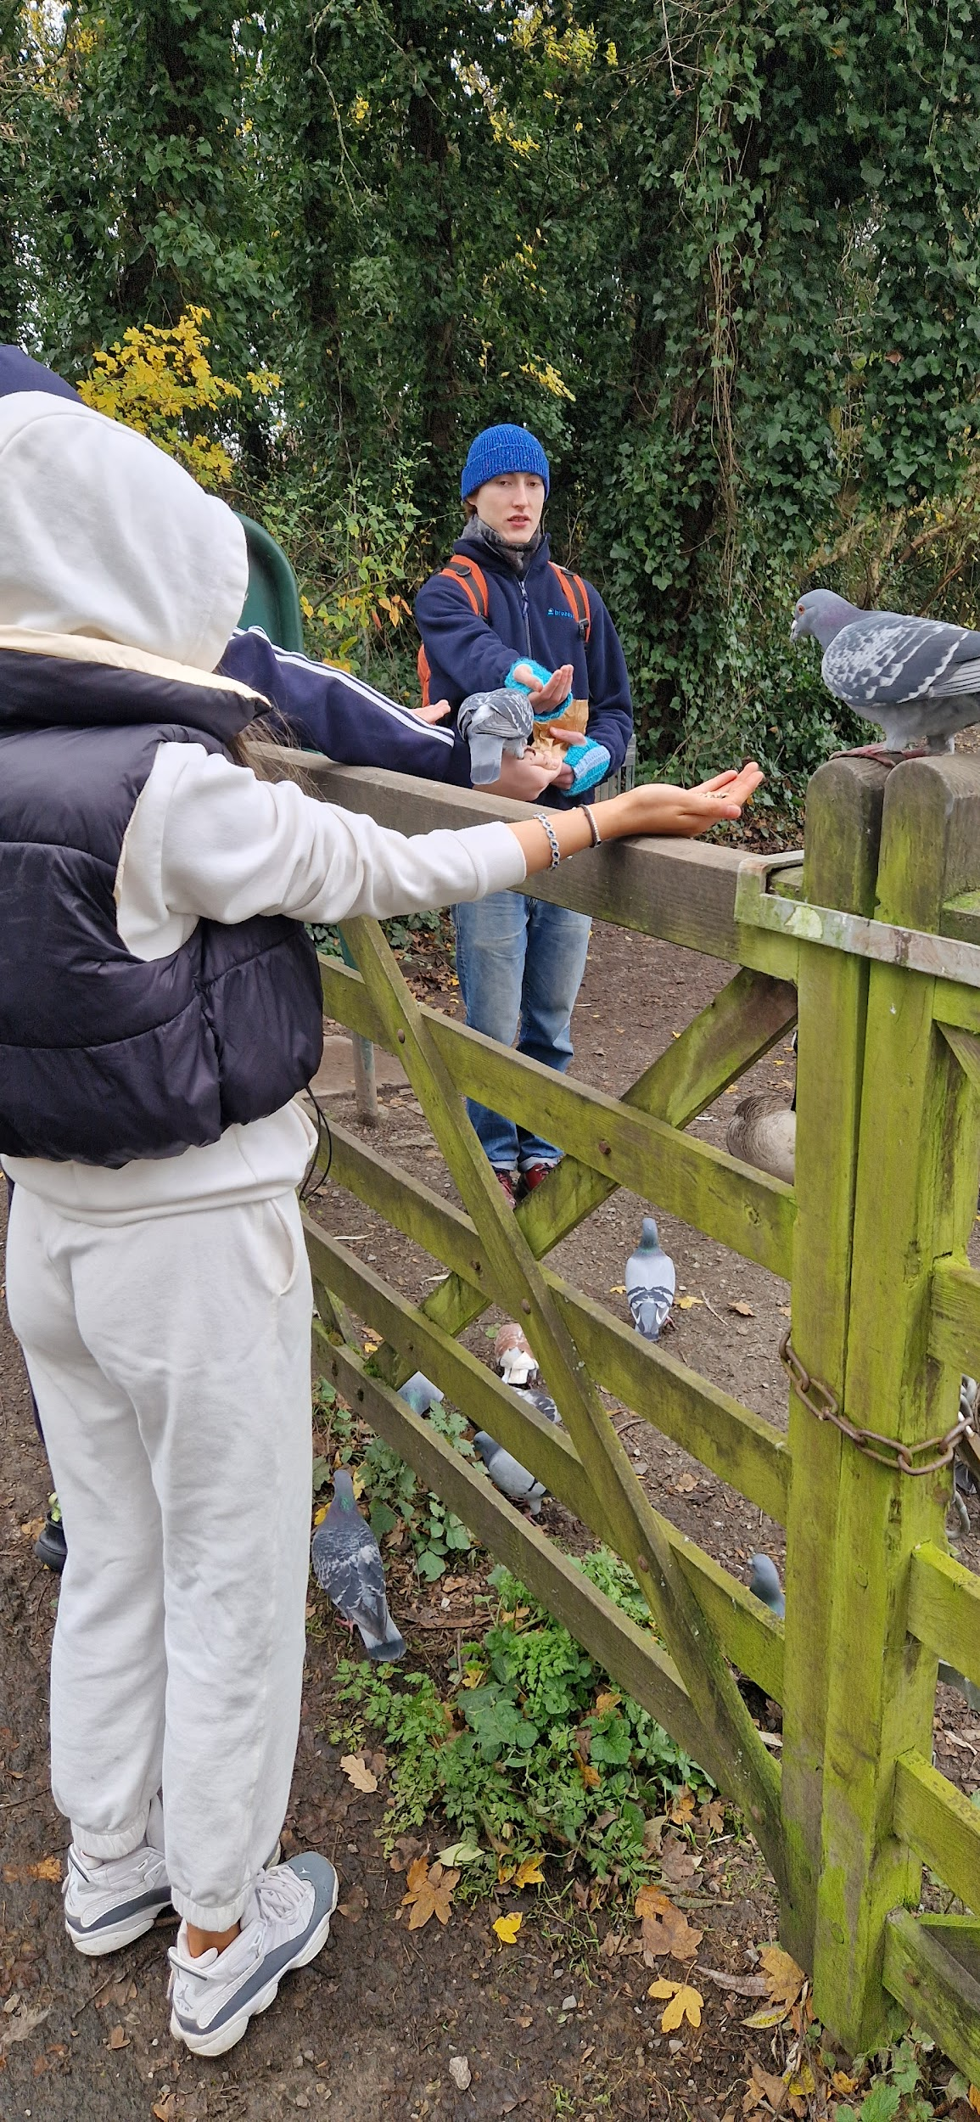
Hand-feeding the one-legged pigeon

Also, as part of a PSHE lesson, Claire and Alex took their Year 10s (as part of their Independent Travel unit), to Staircase House, Stockport.

The house was first built in 1460 and last lived in 1952. Each room is
decorated in a particular era and some of the early walls were uncovered to show the wattle (sticks) and daub (mud and straw) used in the early years.

Everyone enjoyed the trip and learned about decor through time.

Pantomime Trip


It was during our visit to The Plaza Tea Rooms that it came to our attention that Peter Pan was showing at the theatre over Christmas.

Without delay, a school pantomime trip was arranged as part of our PSHE Christmas festivities. Oh Yes it Was!

It is expected that all pupils and staff attending on 20th December will have a lovely time - more details on that in our New Year edition.

Music with Ryan

Ryan, our music teacher, organised a wonderful trip to Chetham’s School of Music in Manchester for pupils in all year groups in PSHE.

Our pupils, while at this prestigious and renowned school, were treated to some very classical renditions from three different performers - a pianist, a trumpeter and a singer.

It was lovely for them to experience this formal setting, and appreciate music of a different type that they hadn’t necessarily had accessed before.

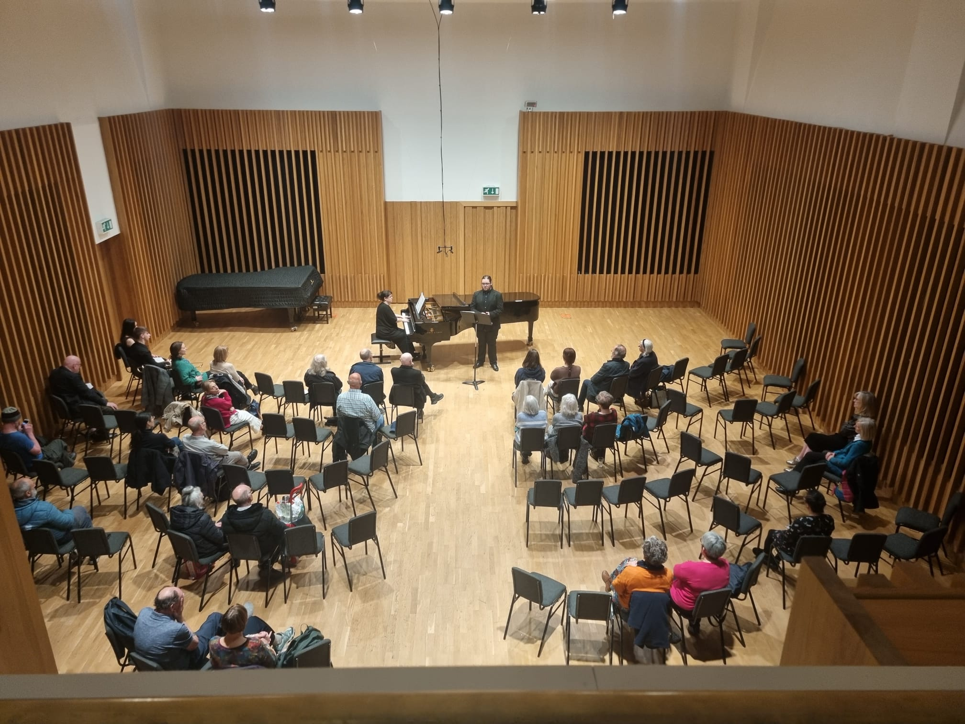
Performers and audience on the day of the visit

*****

Christmas Celebrations

Where’s Elfie?

Rumour had it that Ryan (music teacher) had been secretly and covertly dressing as Elfie and hiding in various places across the different school sites, just for fun.

Seeing an opportunity, Dave (Deputy Headteacher) decided to validate this behaviour by turning it into a whole school Christmas competition.

He captured some of Elfie’s antics on camera and asked staff and pupils to try to guess the whereabouts of Elfie on different days.

So for the last 23 days of our December term, staff and pupils secretly recorded these secret locations in an effort to become the Where’s Elfie? champion.

You will have to wait until our first 2024 edition of the Broadstones newsletter to discover the winner of the Elfie prize.

Just some of the covertly captured images of Elfie during the month of December:

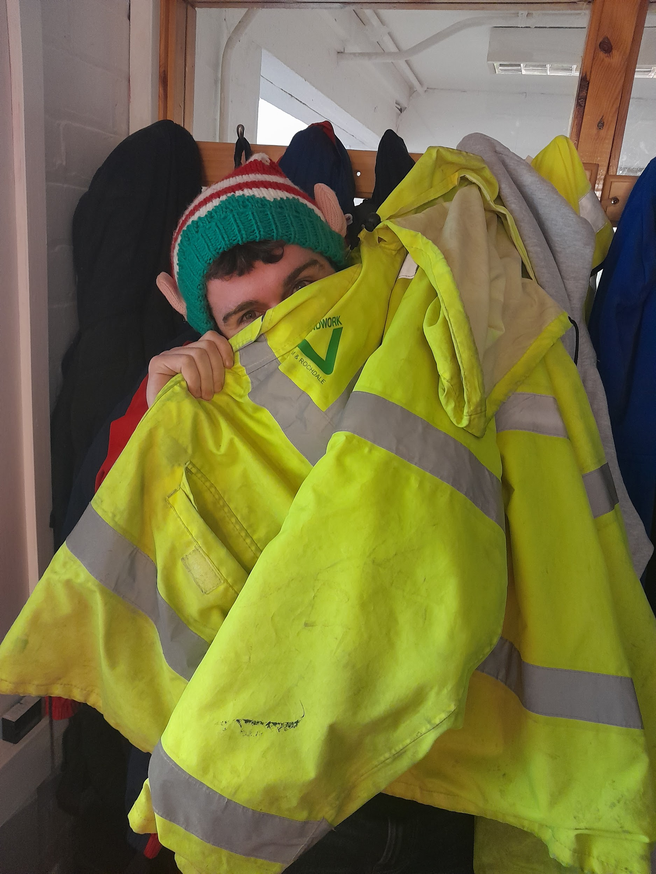
Peek-a-boo Elfie

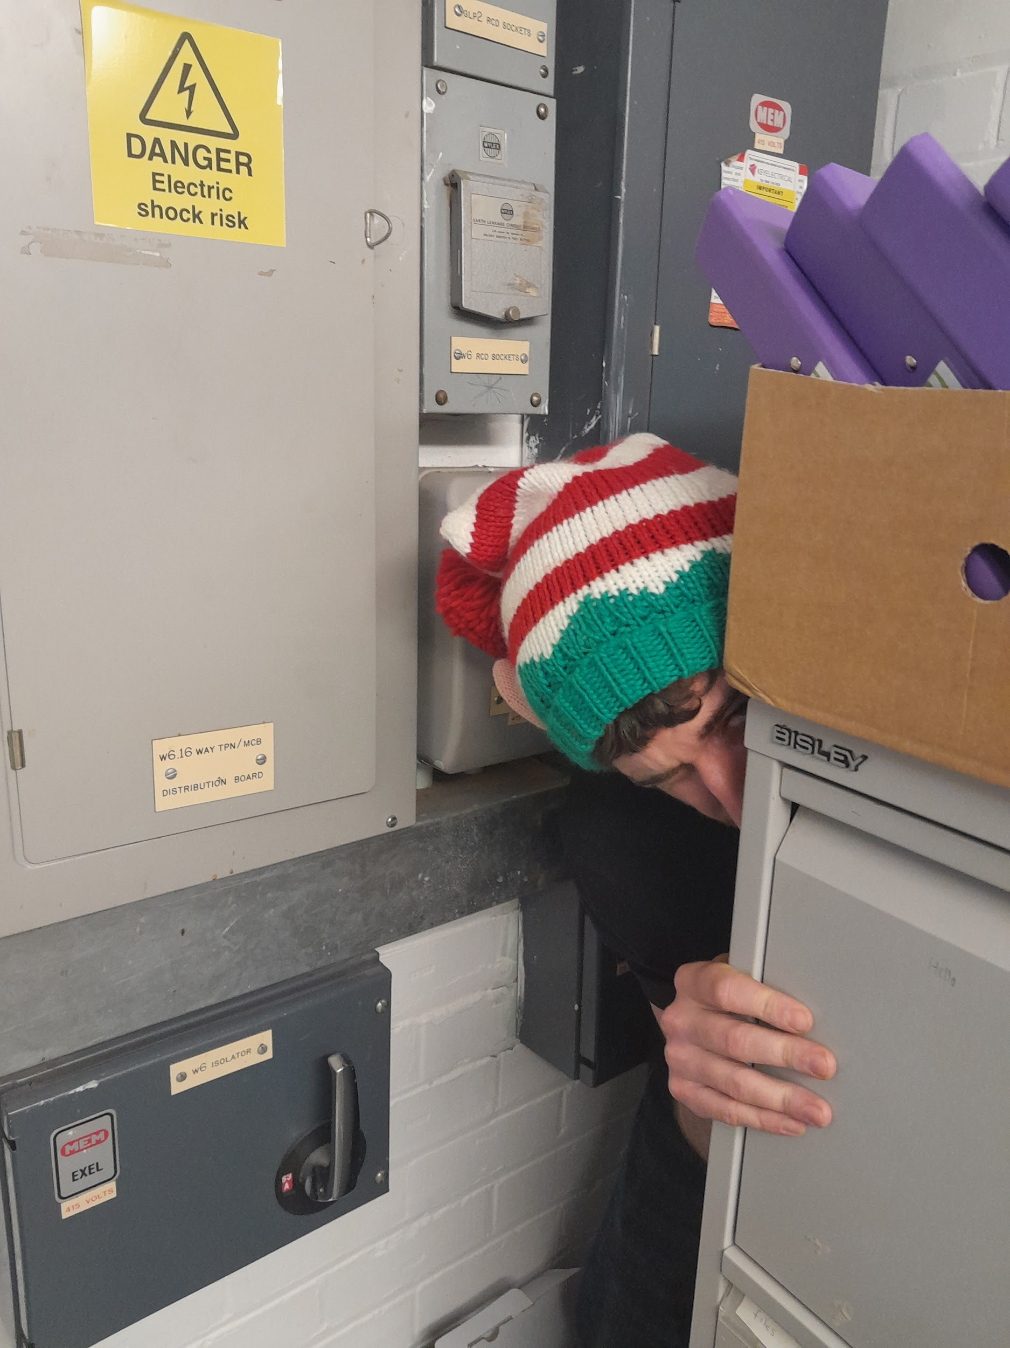
You can run but you can’t hide

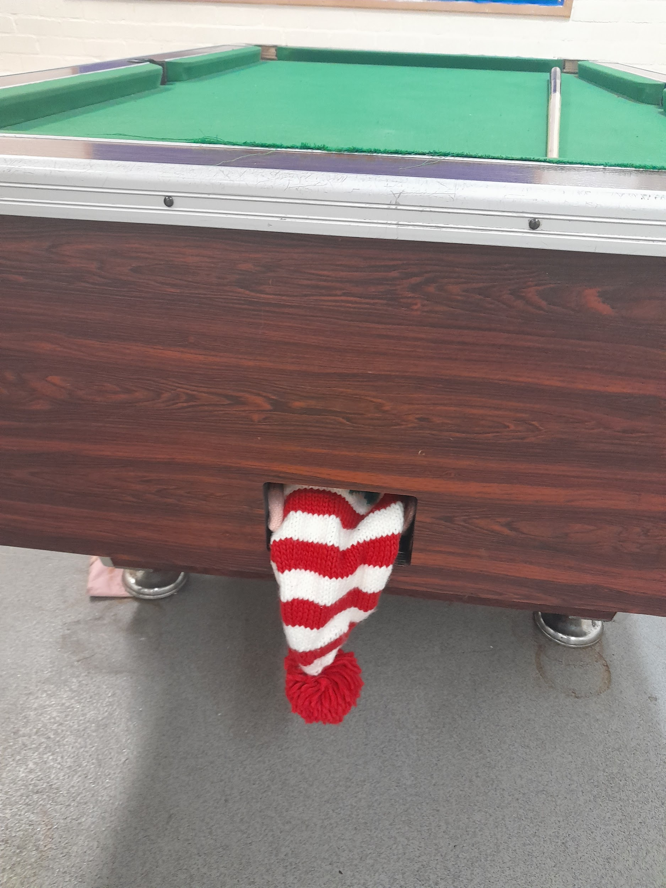
He even managed to get into the pool table?

*****

Christmas Meals

After much deliberation, the Year 11 PSHE group decided that they wanted to celebrate their Christmas with a meal at Frankie and Benny’s.

A lovely time was had by all; the food and behaviour of our pupils was impeccable.

And we look forward to our next scheduled Easter meal!

However, Year 10 opted for a more traditional Christmas fayre, with a Christmas dinner at the Stablegate.

Again, a wonderful time was had by all. Pupils at both venues took full part in the planning process; ordering their own meals and demonstrating perfect representation of the pupils of Broadstones School.

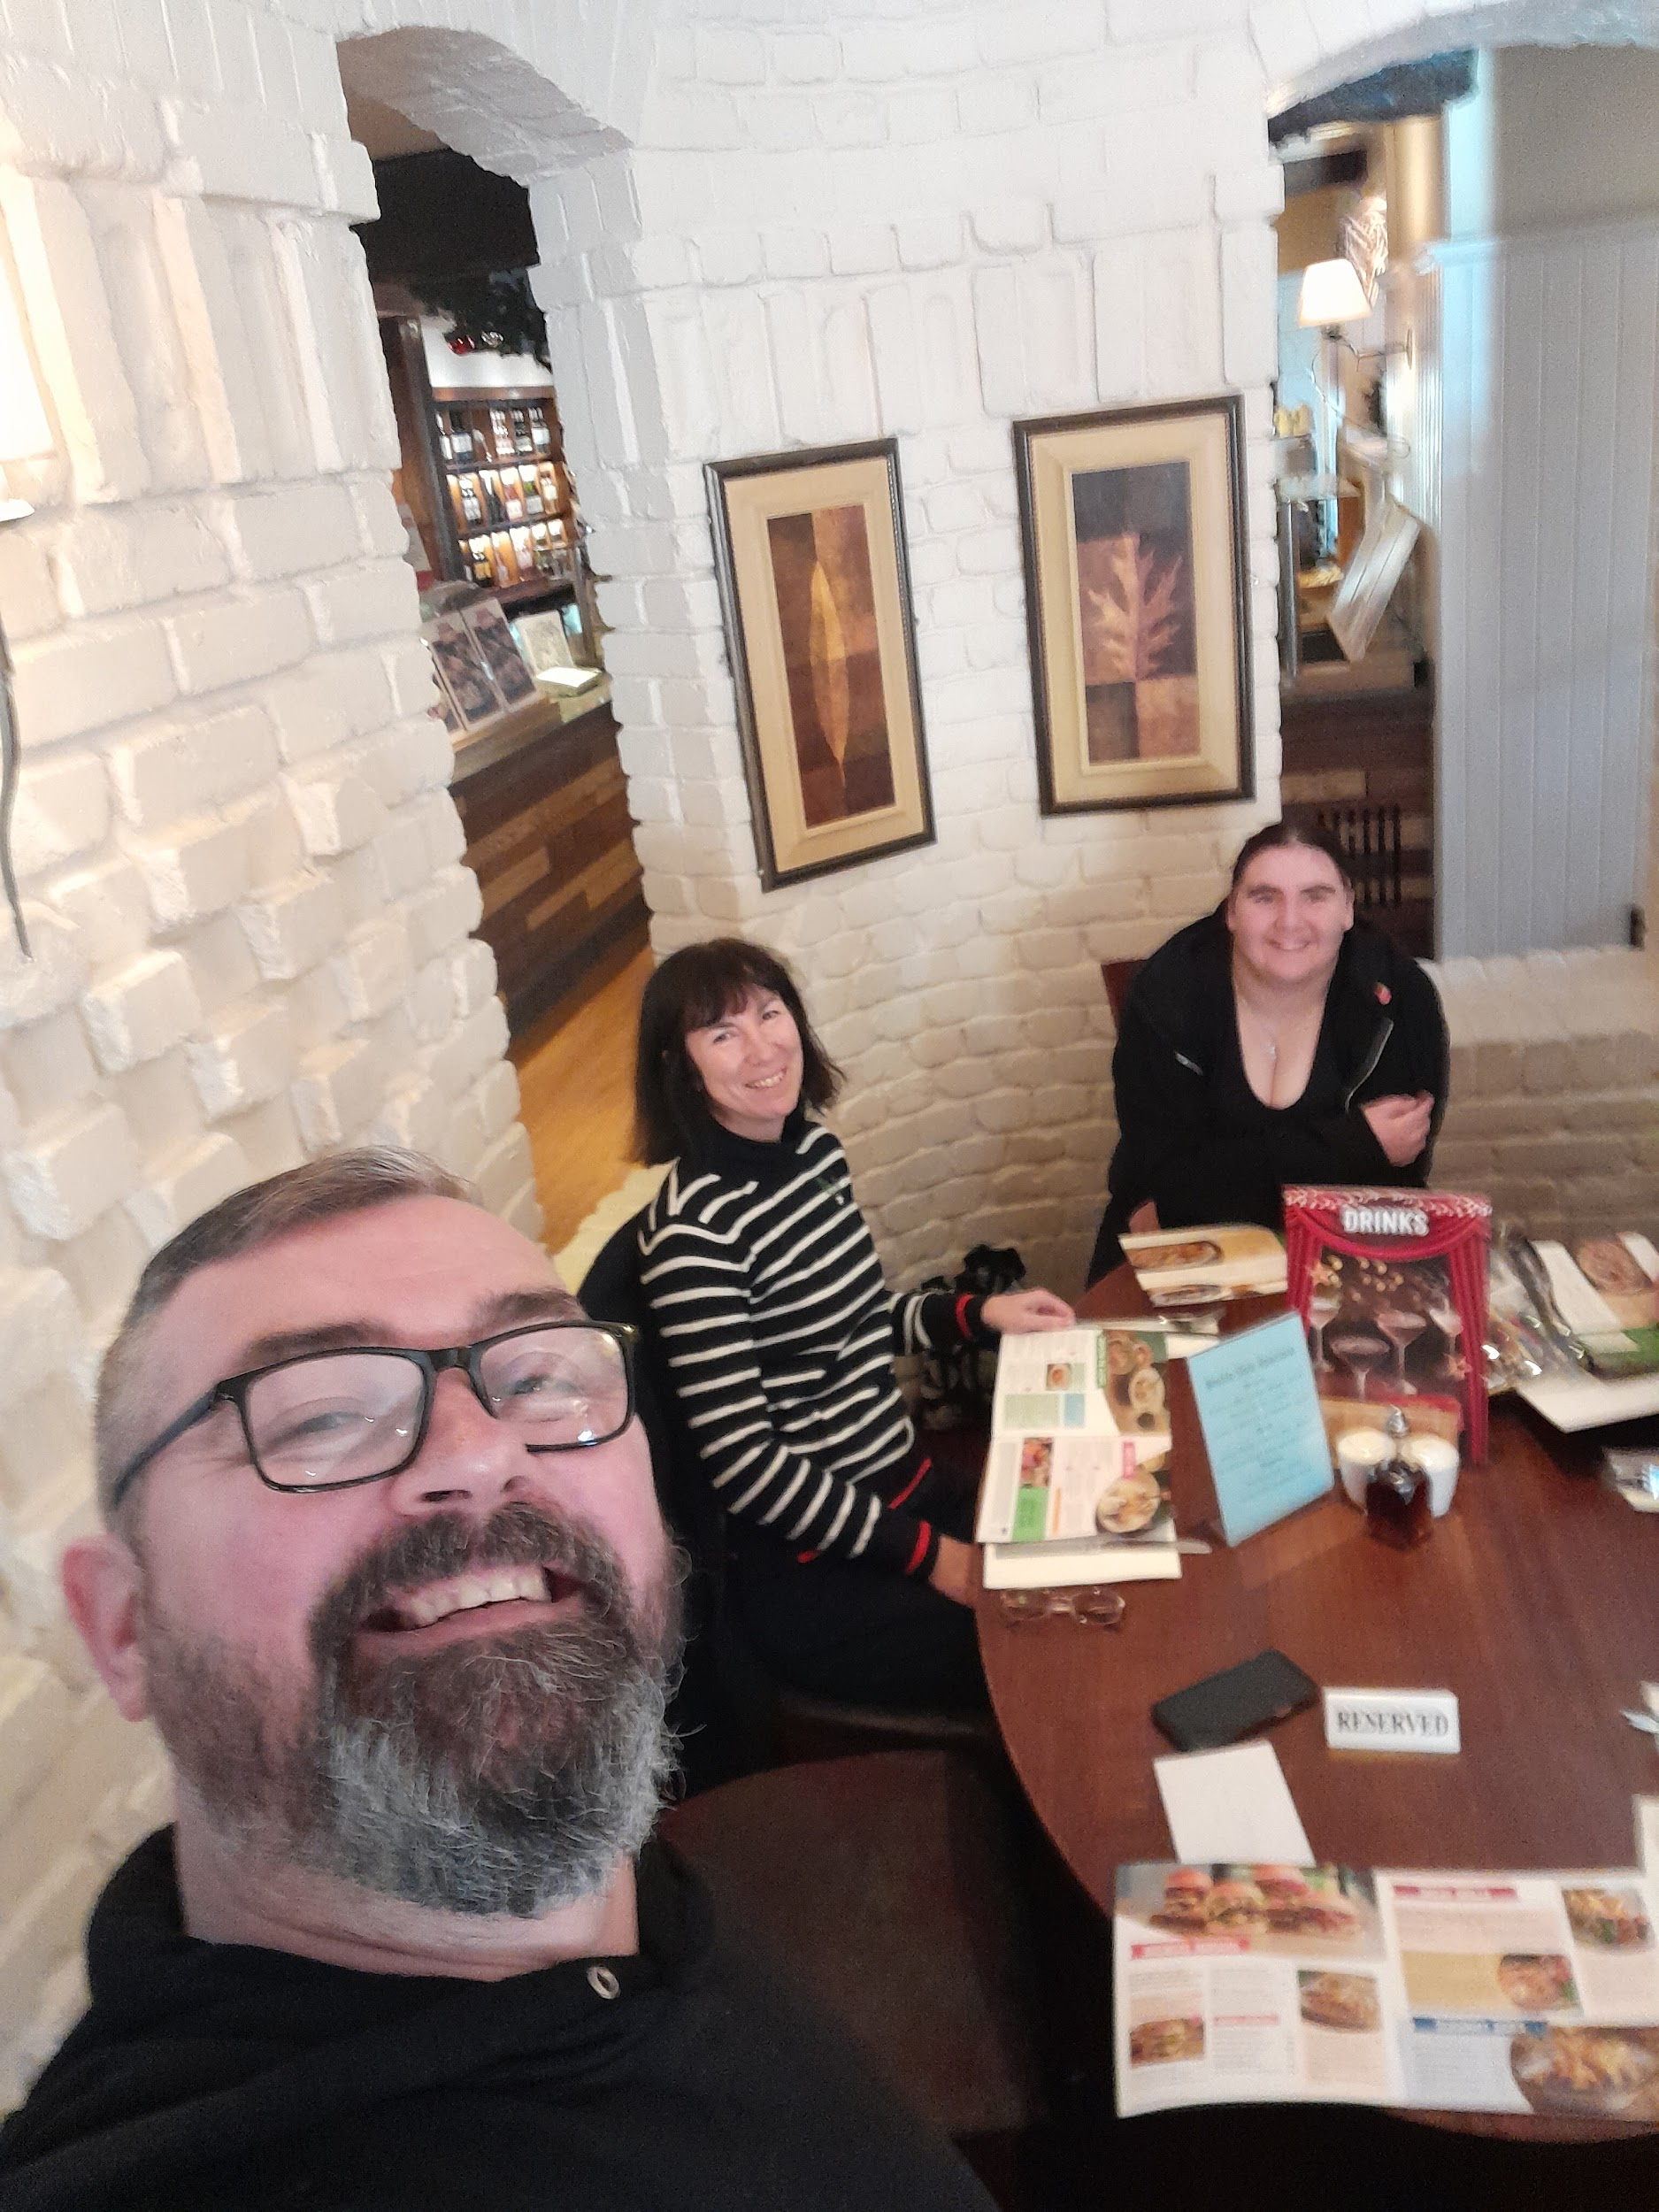

Year 10 at the Stablegate traditional fayre.

*****

Cash for Kids

Cash for Kids is a national charity that helps provide gifts for children living in poverty at Christmas time.

Nicola, our Attendance Officer and member of the school support team has embraced the Christmas spirit this year by volunteering for the Cash for Kids charity.

She collected donations of gifts and delivered them to the Cash for Kids headquarters and helped distribute them to children who might not otherwise have received a Christmas present.

Anyone can donate to this fantastic cause by dropping off their gift at their local drop off centre.

Great work Nicola!

*****

What’s On The Horizon?

Take a quick look at some of the plans for 2024



Sexual Health visit planned for New Year

As part of our PSHE curriculum, all year groups will benefit from a visit from specialised staff, experts at communicating this important subject to young people.

This will take place in January and will involve a full presentation and advice from an outside agency.

Planting the Seeds of Success
At the end of November, Dave and Davina visited an event at Stockport Library designed to help schools and communities to get involved with green projects such as gardening, growing fruits and vegetables, even tree planting.
It is our intention to work more closely with some of these organisations in the new year on an on-going basis to give our pupils some real hands-on experience in this area and hopefully start to develop those green fingers as well as a generally greener mind-set.
We plan to implement this into our PSHE lessons, as well as using it as a springboard for looking at wider green issues such as environmental matters, recycling and how we can all become more green in our everyday living.

*****

And Finally, our 2023 Christmas puzzle!

- What is red and white, red and white, and red and white again?
Answer: Santa Claus falling down a hill.
- If the end of the year is December, what is the end of Christmas?
Answer: The letter 's'.

Editor of this edition:
Davina Rothwell davinarothwell@broadstonesschool.co.uk

School Office :
Room 413, 4th Floor, Broadstone Mill, Broadstone Rad, Reddish, Stockport, SK5 7DK

Tel: 0161 820 1974

Useful Contact Numbers

KOOTH: On-line mental health support for 11-18 year olds:
MOSAIC: (Drugs & Alcohol Services: 0161-218-1100
MASSH: (Multi Agency Safeguarding Hub: 0161-217-6028

