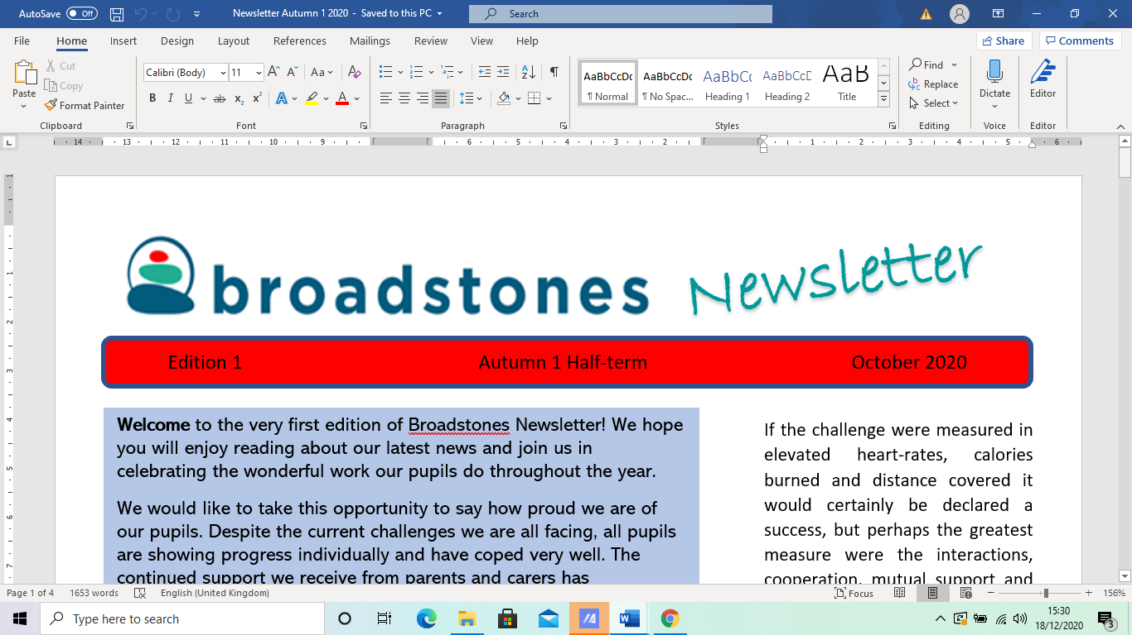

E



***Welcome to***

***Broadstones Christmas edition of the half-term newsletter!***

***As we sail towards Christmas, we reflect on what has been a very busy and productive half term.***

Having settled into the new school year, there’s been lots of activities both in school and offsite: The Worker Bee Market, the football match against Castlehill and so much more.

Enjoy the newsletter and wish you all a very happy and peaceful Christmas and a prosperous new year!

**Halloween Competition Results**



Well done to Alex, our Bikes teacher who accurately worked out that the pumpkin, laden with sweets, weighed exactly 2kg.

Being the good sport Alex is, he passed his prize of the pumpkin laden with sweets to pupils, as he is on a diet.



Alex said: “ I guess I just have a talent for guessing the weight of things.”



On November 19th, Broadstones School took part in another fantastic family fun day with lots of stalls and activities. It was great to see so many pupils with parents and carers.

We raised money for the school by selling items made in Art, Construction, Bikes and the Salon, who offered hair braiding, tattoos, tombola and much, much more. It was a great day and we look forward to next year’s Bee Market.

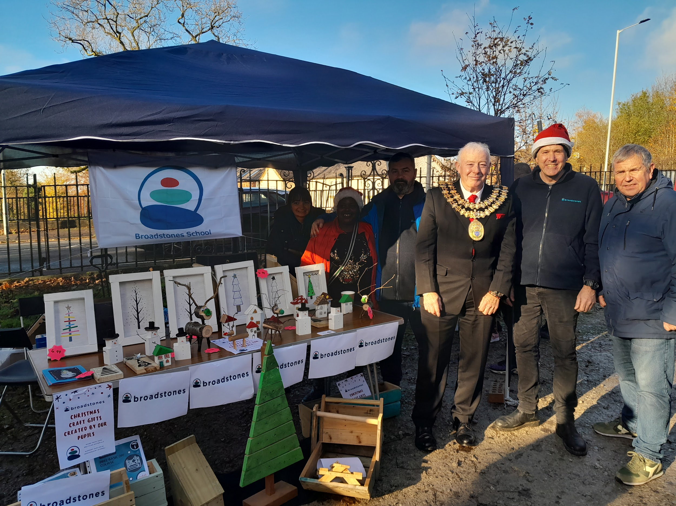

**Dave, Tony and the Mayor at our Bee Market stall**

**Football Match Against Castle Hill**

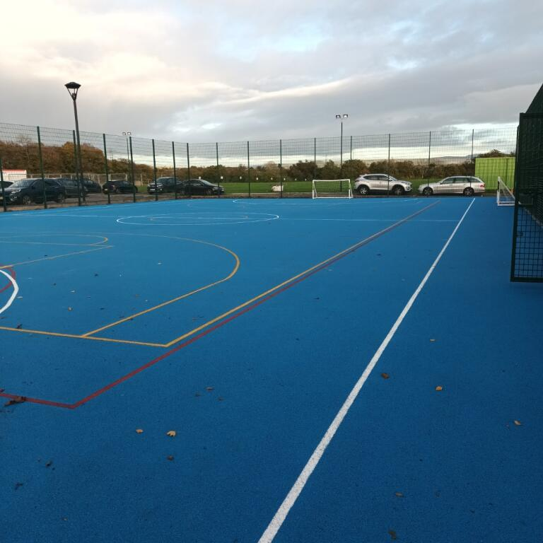

Paul, our wonderful PE Teacher, took our school football team to Castlehill School on Friday 18th November for a pre-Christmas friendly match.

It’s not the first time Broadstones have come up against this team. Back in 2021, we played Castlehill at the inter-schools football tournament in Reddish, whereby we conceded a 2.0 defeat to Castlefields.

On a similarly soaking wet occasion, history was about to repeat itself. Castlehill came up trumps again with a well deserved 3.1 win. Our team didn’t make it easy for them though, and Richard the goalkeeper particularly shone.

The first half saw Richard taking a torrential hammering as Castlehill relentlessly blasted one, after the other.

It’s thanks to Richard’s sheer determination that only a few shots succeeded. Castlehill seemed to benefit from a particularly young talented player whose defending and attacking abilities make him one to look out for.

However, Broadstones put up a strong defence before finally conceding a 3,1 defeat.

It was Henry that scored our goal as well as contributing a few notable moves to the game.

All in all it was a great match to watch with a real sense of teamwork and mutual respect between both teams sealed with handshakes all round at the end of the match.

**Delivery Workshops to the Community**

Broadstones school has now started delivering practical workshops in various subjects to members of the community.

On Thursday evenings, workshops take place at the salon site and at the vale site, giving practical tips and ideas such as help fixing bikes, hair and beauty tips and general advice relating to basic construction.

If you are interested in any of our activities, please contact the school for more details.

**Ambassador Update**

Conor is excelling in his new role as school ambassador. He has helped our new learners settle into school life, organised competitions, supported Lou in the kitchen and even helped out during lessons helping learners with their artwork and construction.

**Well Being Day**

Thanks to Sue and John for our annual staff Wellbeing Day on 25th November.

Staff enjoyed a jaunt on the Vale to help garner inspiration for their given group project.

Groups had two hours to prepare a presentation, inspired by nature and the school ethos, for Sue, John and Liz (Chair of the school committee).

It was a close call with all groups scoring an average of 4 points with their various eclectic and unique perspectives on the given task.

The winners were Claudia and Ryan’s group who created a performance and lovely video on how phones can be used in school in a positive way.

Some lovely images were captured on the vale to help with their presentation.

**Bikes with Alex**



Broadstones has recently helped a local Syrian refugee.

The 16 year old boy was donated one of the school’s bikes - a 16 gear mountain bike, helmet and hi-viz jacket.

Alex said: “It’s always very rewarding to help those in need. This bike will give him so much freedom to explore his new environment. He was immensely grateful and humbled by our generosity.”

**Guest Speakers**

Thanks to Jackie, the school’s Pastoral support lead who has been organising guest speakers to talk to our learners about important health matters.

KOOTH, the organisation that helps young people to manage stress and anxiety will visit our school in December. Our learners will benefit greatly from these talks and take a lot from them. We thank both organisations for their time and input.

**Any Suggestions, please?**



Broadstones has introduced a Suggestion Box to be placed in the Vale site so that learners have a specific platform for airing their ideas.

This is a great idea and we hope to be able to act upon as many of our learners’ suggestions as possible.

**Notice Boards**



The school has also organised a pupil-friendly notice board to go up in the vale site so that learners can see at a glance events, information, achievements, etc, that are current in school.

In addition to this, a Gateway Board is also to be established so that learners can see at a glance where they are individually up to on their specific course.

These boards will help immensely with communication on many levels and we look forward to benefiting from this exciting undertaking.

**Parents Post-Christmas**

**Social Event**

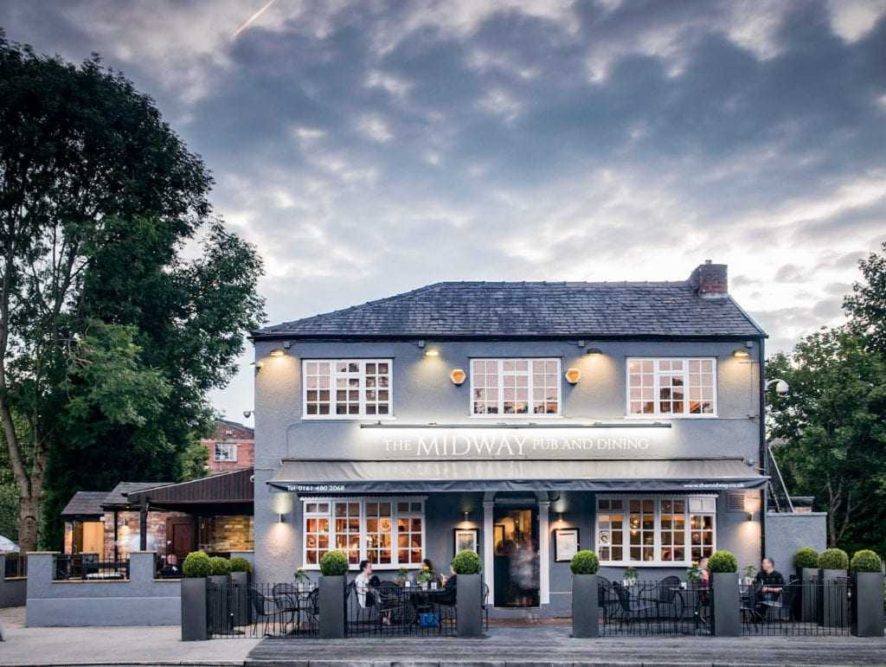

Broadstones is holding a post-Christmas social event for parents and carers in early January 2023.This event is to take place with senior members of staff, in the Midway pub in Stockport, on Thursday 19th January, with 3 sessions available throughout the day.

This informal setting is designed to offer parents and carers a light-hearted and relaxed venue, so they can enquire about the school in general as well as discuss their child’s progress in school.

We look forward to seeing as many of you as possible! A leaflet was sent out to parents in November.

**OutReach with**

**Sue and Ellen**

Broadstones Outreach regularly collects Feedback from the parents/carers of pupil’s who access our service.

We always give them the opportunity to share their ideas on how we could improve our service, as well as any positive comments on how our service has benefitted their children.

Please see below for some parental suggestions, and how we have acted on these:

**You Said** that you wanted pupils to have

*‘More opportunities for socialising with pupils of their age’*

**Our response:**

We are aware that this has at times been an issue within vocational sessions, and has been linked to lockdown/attendance issues.

We now have a cohort of pupil’s whose attendance is far more consistent, and this allows pupil’s more opportunities to mix with peers of their age and to develop positive friendships.

**You Said:**

***‘It would be nice to see some of the work my child does, or has done, at the vocational centre’***

**Our response:**

This has been discussed with vocational staff and SMT and staff have begun sharing evidence of pupil’s work with parents.

There is also the opportunity to see and to buy pupil’s work from Construction, and to attend local Bee Markets where pupil’s work is sold (all parents are invited to attend).

*****

**Christmas Quiz**



*Can you answer our Festive Questions?*

1. Which country first started the tradition of putting up a Christmas tree?

2. What do people traditionally put on top of their Christmas tree?

3. What Hollywood actor played six different roles in *The Polar Express*?

4. What are the traditional 12 days of Christmas?

5. What are the chances of a white Christmas in the UK?





**Need help or support over the holiday season???**

***The Christmas holidays can sometimes be difficult to navigate, when lots of things are going on, so if you need support over the holidays, here are some useful contact numbers***

**KOOTH: (On-line mental health support for 11-18 year olds): 0800 1111**

**MOSAIC: (Drugs & Alcohol Services): 0161-218-1100**

**MASSH: (Multi Agency Safeguarding Hub): 0161-217-6028**

